Revolutionizing Human Services Software

HOPWA Reporting
Version 5.0● July 5, 2016

CaseWorthy, Inc.
3995 South 700 East
Suite 420
Salt Lake City, Utah
84107
Tel: 877-347-0877 Fax: 801-207-8350
Last edited: 05 July 2016
Copyright © 2010 CaseWorthy, Inc. All rights reserved.
No part of this publication may be reproduced, transmitted, transcribed, stored in a retrieval system, or translated into any language, in any form or by any means, electronic, mechanical, photocopying, recording, or otherwise, without prior written permission from CaseWorthy, Inc.
All copyright, confidential information, patents, design rights and all other intellectual property rights of whatsoever nature contained herein are and shall remain the sole and exclusive property of CaseWorthy, Inc. The information furnished herein is believed to be accurate and reliable.
However, no responsibility is assumed by CaseWorthy, Inc. for its use, or for any infringements of patents or other rights of third parties resulting from its use.
The CaseWorthy™ name and logo are trademarks or registered trademarks of CaseWorthy, Inc.
All other trademarks are the property of their respective owners.

Table of Contents
Introduction to CaseWorthy™ Reporting 2
About CaseWorthy™ Reporting 2
Locating the Reports Menu Group 2
Report Dashboard Introduction 2
Compliance Reports Menu 2
Key Terms 3
Definition of Key Terms 3
Report Specifications 6
Report Details 7
Report Set Up 18
Provider HMIS Set Up 19
To access the Provider HMIS Setup 19
To set up HMIS information for Providers 21
Program HMIS Set Up 21
To access Program HMIS Setup 21
Report Mapping 23
Map Services 24
Map Financial Services 25
Mapping HMIS Participating Programs 27
Launching the Report 27
Report Launch page options 27
Report Navigation 29
Navigating the CaseWorthy™ baseline report 29
Exporting Data 30
Export Icon 30
Excel Spreadsheet Export 30

Introduction to CaseWorthy™ Reporting

About CaseWorthy™ Reporting
This User Guide provides agencies with specific requirements for generating reports on the Housing Opportunities for Persons with AIDS to enable organizations to effectively report out quantitative measures of Annual Progress Report. For more info visit: https://www.hudexchange.info/hopwa/

Locating the Reports Menu Group
The HOPWA report is located on the Administration workspace. To access the Administration workspace, click the Administration icon in the upper-left portion of the screen. Once in the Administration tab, click the Reporting menu group located at the bottom of the taskbar list.
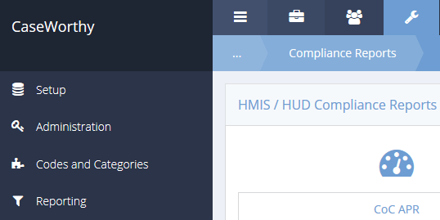

Report Dashboard Introduction
The CaseWorthy™ Reporting menu group is designed to assist agencies with their reporting needs. To ensure only authorized users can run and view reporting, the menu will only display for users with the level of Administrator. To allow users with less than an Administrator user level requires a custom role to be created and the menu item to be modified.

Compliance Reports Menu
When selecting the Compliance Reports menu group the system will display the Compliance Reports dashboard. Identify the icon labeled HMIS APR and select it.

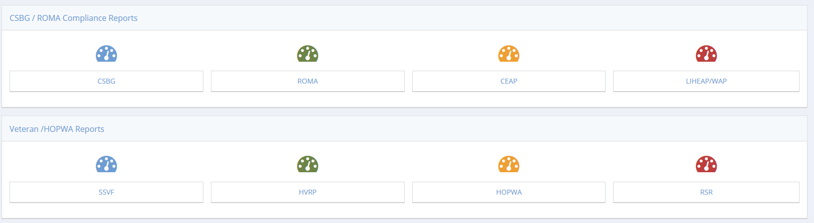

Key Terms

Definition of Key Terms
Adjustment for Duplication: Enables the calculation of unduplicated output totals by accounting for the total number of households or units that received more than one type of HOPWA assistance in a given service category such as HOPWA Subsidy Assistance or Supportive Services.

Beneficiary(ies): All members of a household who received HOPWA assistance during the operating year including the one individual who qualified the household for HOPWA assistance as well as any other members of the household (with or without HIV) who benefitted from the assistance.

Chronically Homeless Person: An unaccompanied homeless individual (age 18 years or older) with a disabling condition or a family with at least one adult member (age 18 years or older) who has a disabling condition who has either been continuously homeless for a year or more OR has had at least four episodes of homelessness in the past three years.” For this purpose, the term “homeless” means “a person sleeping in a place not meant for human habitation (e.g., living on the streets) or in an emergency homeless shelter.”

Disabling Condition: Evidencing a diagnosable substance use disorder, serious mental illness, developmental disability, or chronic physical illness or disability, including the co-occurrence of two or more of these conditions. In addition, a disabling condition may limit an individual’s ability to work or perform one or more activities of daily living. An HIV/AIDS diagnosis is considered a disabling condition.

Facility-Based Housing Assistance: All eligible HOPWA Housing expenditures for or associated with supporting facilities including community residences, SRO dwellings, short-term facilities, project-based rental units, master leased units, and other housing facilities approved by HUD.

HOPWA Eligible Individual: The one (1) low-income person with HIV/AIDS who qualifies a household for HOPWA assistance. This person may be considered “Head of Household.” When the APR asks for information on eligible individuals, report on this individual person only. Where there is more than one person with HIV/AIDS in the household, the additional PWH/A(s), would be considered a beneficiary(s).

HOPWA Housing Placement Assistance Activity Total: The unduplicated number of households receiving assistance with either housing information services or permanent housing placement. These services are dedicated to helping persons living with HIV/AIDS and their families to identify, locate, and acquire housing.

HOPWA Housing Subsidy Assistance Total: The unduplicated number of households receiving housing subsidies (TBRA, STRMU, and Master Leasing) and/or residing in units of facilities dedicated to persons living with HIV/AIDS and their families and supported with HOPWA funds during the operating year.

Household: A single individual or a family composed of two or more persons for which household incomes are used to determine eligibility and for calculation of the resident rent payment. The term is used for collecting data on changes in income, changes in access to services, receipt of housing information services, and outcomes on achieving housing stability. Live-In Aides (See definition for Live-in Aide below) and non-beneficiaries (e.g. a shared housing arrangement with a roommate) who resided in the unit are not reported on in the APR.

Housing Stability: The degree to which the HOPWA project assisted beneficiaries remain in stable housing during the operating year. See Part 6: Worksheet definitions of stable and unstable housing situations.

In-kind Leveraged Resources: These involve additional types of support provided to assist HOPWA beneficiaries such as volunteer services, materials, use of equipment and building space

Leveraged Funds: The amount of funds expended during the operating year from non-HOPWA federal, state, local, and private sources by grantees or sponsors in dedicating assistance to this client population. Leveraged funds or other assistance used directly in HOPWA program delivery.

Live-In Aide: A person who resides with the HOPWA Eligible Individual and who meets the following criteria: (1) is essential to the care and well-being of the person; (2) is not obligated for the support of the person; and (3) would not be living in the unit except to provide the necessary supportive or services.

Outcome: The HOPWA assisted households who have been enabled to establish or better maintain a stable living environment in housing that is safe, decent, and sanitary and to reduce the risks of homelessness, and improve access to HIV treatment and other health care and support.

Output: The number of units of housing or households that receive HOPWA assistance during the operating year.

Permanent Housing Placement: A supportive housing service that helps establish the household in the housing unit, including but not limited to reasonable costs for security deposits not to exceed two months of rent costs.

Project-Based Rental Assistance (PBRA): A rental subsidy program that is tied to specific facilities or units owned or controlled by a project sponsor. Assistance is tied directly to the properties and is not portable or transferable.

Short-Term Rent, Mortgage, and Utility (STRMU) Assistance: A time limited housing subsidy assistance designed to prevent homelessness and increase housing stability. Grantees may provide assistance for up to 21 weeks in any 52 week period.

Stewardship Units: Units developed with HOPWA, where HOPWA funds were used for acquisition, new construction and rehabilitation that no longer receive operating subsidies.

Subrecipient Organization: Organizations that hold an agreement with the grantee or sponsor agencies to provide administrative or limited implementation activities that do not involve direct services to clients.

Tenant-Based Rental Assistance (TBRA): TBRA is a rental subsidy program similar to Section 8 that grantees can provide to help low-income households access affordable housing. The TBRA voucher is not tied to a specific unit, so tenants may move to a different unit without losing their assistance, subject to individual program rules. The subsidy amount is determined in part based on household income and rental costs associated with the tenant’s lease.

Transgender: Transgender is defined as a person who identifies with, or presents as, a gender that is different from his/her gender at birth.

Report Specifications

Services Provided: Services should be recorded for the client in the household with HIV/AIDS to whom they were provided; a service that benefits the whole household may be recorded solely for the head of household. For each service provided, projects should record the service date and service type.

Financial Assistance: Financial Assistance records payments made by the project on behalf of or for the benefit of the client. For each instance of the financial assistance provided, there should be one and only one record created. Records of financial assistance should be attached to the head of household.

Medical Assistance: Enter the date on which the information was collected. For each source of medical assistance listed below, determine if the client is presently receiving the medical assistance specified. Clients may identify multiple sources of medical assistance. If the client is not receiving medical assistance, enter the reason why such insurance is not being received.

PART 3. Summary Overview of Grant Activities
A. Information on Individuals, Beneficiaries, and Households Receiving HOPWA Housing Subsidy Assistance
Section 1. Individuals
a. Total HOPWA eligible individuals*receiving HOPWA Housing Subsidy Assistance
Section 2. Beneficiaries
Section 3. Households
Household Area Median Income
B. Sources of Leveraging and Program Income
Sources of Leveraging
Program Income and Resident Rent Payments
Program Income and Resident Rent Payments Expended To Assist HOPWA Households
C. Performance and Expenditure Information
1. Performance and Expenditure Information by Activity Type

PART 4. Summary of Performance Outcomes: Housing Stability, Prevention of Homelessness, and Access to Care
Section 1. Housing Stability: Assessment of Client Outcomes on Maintaining Housing Stability (Permanent Housing and Facilities)
Section 2. Prevention of Homelessness: Assessment of Client Outcomes on Reduced Risks of Homelessness
Section 3. Access to Care and Support: Assessment of Client Outcomes on Access to Care and Support
1c. Households that Obtained Employment

PART 5. Summary of Each Project Sponsor(s)/Sub recipient(s) Information
A. Project Sponsor and Sub recipient Information
B. Rental Assistance , Short-Term Rent, Mortgage, and Utility Assistance, and Permanent Housing Placement Assistance
C. Facility-based Housing Assistance
D. Supportive Services and Other Activities
E. Annual Certification of Continued Use for HOPWA Facility-Based Stewardship Units
PART 6. Worksheet - Determining HOPWA Outcomes and Connections with HMIS

Report Details

Part 3: Summary Overview of Grant Activities
A. Information on Individuals, Beneficiaries, and Households Receiving HOPWA
Individuals - Reporting for this section should include ONLY those individuals Enrolled in a HOPWA program, beneficiaries, or households that received HOPWA Housing Subsidy Assistance. HOPWA Enrollments include only the eligible individual, do not add additional enrollment members.
Part 3 | Section 1. Individuals |  | Data reported in this category is derived from:
a. | Number of individuals with HIV/AIDS who qualified their household |  | Total of HOPWA Enrollments based on date range and Organization(s) selected
4.3 b. Prior Living Situations - In Row 1, report the total number of individuals who continued to receive HOPWA housing subsidy assistance from the prior operating year. In Rows 2 through 17, indicate the prior living arrangements at Entry for all new Enrollments during the operating year.
 | HOPWA Data Categories |  | Data reported in this category is derived from:
1. | 4.3.1 Continuing to receive HOPWA housing subsidy assistance from the prior operating year |  | Enrollment begin date prior to the report begin date
 | 2 - 17 Enrollment begin date > Report Start Date |  | AssessHUDUniv_PriorResidence
2. | Place not meant for human habitation |  | # 14
3. | Emergency Shelter |  | # 1
4. | Transitional housing for homeless persons |  | # 2
5. | Total number of Homeless |  | Sum of rows (2, 3 & 4)
6. | PH for formally Homeless |  | # 3
7. | Psychiatric hospital or other psychiatric facility |  | # 4
8. | Substance abuse treatment facility or detox center |  | # 5
9. | Hospital (non-psychiatric facility) |  | # 6
10. | Foster care home or foster care group home |  | # 13
11. | Jail, prison or juvenile detention facility |  | # 7
12. | Rented room, apartment, or house |  | # 8
13. | House you own |  | # 9
14. | Staying or living in someone else's room, apt, or house |  | #10 & #11
15. | Hotel or motel paid for by individual |  | # 12
16. | Other |  | # 15
17. | Don't Know / Refused |  | Includes missing data, 20, 21
18. | Total of HOPWA Eligible Individuals |  | Sum of rows: 1 and 5 - 17
c. Homeless Individuals Summary
Indicate the number of HOPWA eligible individuals homeless Veterans and/or Chronically Homeless
 | Category | Homeless Veteran(s) |  | Chronically Homeless
c. | HOPWA Enrollments | Housing Status - (1) Literally Homeless, Veteran Status (1) Yes |  | AssessChronically Homeless_ Chronic Homeless

Section 2 Beneficiaries
a. Total number of HOPWA eligible individuals living with HIV/AIDS who received HOPWA housing subsidy assistance and all associated members of their household.
1. | Number of individuals with HIV/AIDS who qualified the household | Total Enrollment
2. | Number of ALL other Family members diagnosed as HIV positive | Family members with report Issue mapping to HIV
3. | Number of ALL other persons not diagnosed as HIV positive who reside with the HOPWA eligible individual | All Non HIV/AIDS family members
4. | TOTAL Number of ALL Beneficiaries Served with HOPWA | Sum of Rows 1, 2, & 3

b. HOPWA Eligible Individuals Age & Gender - Enrollment members only
 | Client.DOB | A. |  | B. |  | C. | D. |  | E.
 | Client.Gender | Male |  | Female |  | Transgender M to F | Transgender F to M |  | Sum A - D
1. | Under 18 | #1 |  | #2 |  | #3 | #4
2. | 18 to 30 years
3. | 31 to 50 years
4. | 51 years and Older
5. | Sum rows 1 - 4
HOPWA Eligible Individuals Age & Gender – All Other Beneficiaries
 |  | A. |  | B. |  | C. | D. |  | E.
 | Client.Gender | Male |  | Female |  | Transgender M to F | Transgender F to M |  | Sum A - D
6. | Under 18 | #1 |  | #2 |  | #3 | #4
7. | 18 to 30 years
8. | 31 to 50 years
9. | 51 years and Older
10. | Sum rows 6 - 9
Total Beneficiaries Age & Gender
11. | Total rows 5 & 10 |  |  |  |  |  |  | Sum A - D

c. Race and Ethnicity of all beneficiaries receiving HOPWA Housing Subsidy Assistance
Category |  | HOPWA Eligible Individuals |  | All Other Beneficiaries
 | Client_Race | A. Race | B. Ethnicity | C. Race | D. Ethnicity
1. | American Indian/Alaskan Native | # 1 | 1 Non, 2 HL, 8 DK, 9 Refused | # 1 | 1 Non, 2 HL, 8 DK, 9 Refused
2. | Asian | # 2 |  | # 2
3. | Black/African American | # 3 |  | # 3
4. | Native Hawaiian/Other Pacific Islander | # 4 |  | # 4
5. | White | # 5 |  | # 5
6. | American Indian/Alaskan Native & White | # 15 |  | # 15
7. | Asian & White | # 25 |  | # 25
8. | Black/African American & White | # 35 |  | # 35
9. | American Indian/Alaskan Native & Black/African | # 13 |  | # 13
10. | Other Multi-Racial | Any other # 0 |  | Any other # 0
11. | Sum of Rows 1 - 10

Section 3 Households
Household Area Median Income Area median income(s) for all households served with HOPWA housing subsidy assistance.
Percentage of Area Median Income |  | Enrollment AMI HOPWA Housing Subsidy
1. | 0-30% of AMI (extremely low) | AFSE.PercentOfAMI
2. | 31-50% of AMI (very low)
3. | 51-80% of AMI (low)
4. | TOTAL of ALL Households | Sum 1, 2, & 3

Part 3: Summary Overview of Grant Activities
1. Sources of Leveraging
Sources of Leveraging 1 - 4 | Enter all Manually

2. Program Income and Resident Rent Payment
a. Total Amount Program Income
 |  | Total Amount of Program Income
1 | Program Income (Payments)
2 | Resident Rent Payments made directly to HOPWA
3 | Total Program Income and Resident Rent Payments | Sum of Rows 1 and 2
b. Total Amount Program Income
 |  | Total Amount of Program Income Expended
1 | Program Income and Resident Rent Payment Expended on Housing Subsidy Assistance costs
2 | Program Income and Resident Rent Payment Expended on Supportive Services and other non-direct housing costs
3 | Total Program Income Expended | Sum of Rows 1 and 2

Part 3: Summary Overview of Grant Activities
C. Performance and Expenditure Information
1. Performance and Expenditure Information by Activity Type
HOPWA Housing Subsidy |  |  | 1. Number of Households |  | 2. Amount HOPWA Funds
1. | Tenant-Based Rental Assistance |  | HOPWAType = 1
2a. | Permanent Housing Facilities: |  | HOPWAType = 2,3
2b. | Transitional/Short-term Facilities: |  | HOPWAType = 4,5
3a. | Permanent Housing Facilities:  Capital Development Projects placed in service during the operating year |  |  |  | Entered Manually
3b. | Transitional/Short-term Facilities:  Capital Development Projects placed in service during the operating year |  |  |  | Entered Manually
4. | STRMU Assistance |  | HOPWAType = 6
5. | Perm Housing Placement Services |  | HOPWAType = 8,9
 | TOTAL HOPWA Housing Subsidy |  | Sum 1 - 5 |  | Sum 1 - 5
Housing Development construction |  |  | 1 Housing Units |  | 2. Amount HOPWA Funds
 |  | 8 - 10 |  | Entered Manually |  | Entered Manually
Supportive Services |  |  |  | 1. Number of Households |  | 2. Amount HOPWA Funds
11.a |  | Supportive Services also delivered HOPWA housing assistance |  | IsHousingSubsidyHOPWAType = 1
11b. |  | only provided supportive services |  | IsHousingSubsidyHOPWAType = 2
13. |  | TOTAL Supportive Services |  | Sum 11 a - 11 b |  | Sum 11 a - 11 b

Housing Information Services |  |  | 1. Number of Households | 2. Amount HOPWA Funds
14. |  | Housing Information Services | ComplianceReportLineItemID = 25
Grant Administration and Other Activities |  |  | 1. Number of Households | 2. Amount HOPWA Funds
16. | Resource Identification |  |  | Entered Manually
17. | Technical Assistance |  |  | Entered Manually
18. | Project Outcomes/Program Evaluation |  |  | Entered Manually
19. | Grantee Administration |  |  | Entered Manually
20. | Project Sponsor Administration |  |  | Entered Manually
21. | Other activity |  | ComplianceReportLineItemID = 24 | Entered Manually
22. | TOTAL |  | Sum of Rows 16 - 21 | Entered Manually
TOTAL Expended |  |  | 1] Housing Units | 2. Amount HOPWA Funds
23 | TOTAL Expenditures |  |  | Entered Manually

Part 4: Summary of Performance Outcomes
Housing Stability, Prevention of Homelessness and access to Care
Section 1. Housing Stability: Assessment of Client Outcomes on Maintaining Housing Stability
- Permanent Housing Assistance
Tenant Based Rental Assistance
1. | Number of Households | Enrollments
2. | Households continuing to receive Subsidy Assistance into Next Year | Leavers = 0
3. Leavers - Household Status - Leavers - AssessHUDProgram.exit destinations
1 | ES / Streets | #1
2 | Temporary Housing | #2
3 | Private Housing | #3
4 | Other HOPWA | #4
5 | Other Subsidy | #5
6 | Institution | #6
7 | Jail/Prison | #7
8 | Disconnected/Unknown | #8
9 | Death | #9
10 | Missing Exit Assessment | Is Nothing

Permanent Supportive Housing Facilities/Units
1. | Number of Households | Enrollments
2. | Number of Non-Leavers | Stayers
3. Leavers - Household Status - Leavers - AssessHUDProgram.exit destinations
1 | ES / Streets | #1
2 | Temporary Housing | #2
3 | Private Housing | #3
4 | Other HOPWA | #4
5 | Other Subsidy | #5
6 | Institution | #6
7 | Jail/Prison | #7
8 | Disconnected/Unknown | #8
9 | Death | #9
10 | Missing Exit Assessment | Is Nothing

B. Transitional Housing Assistance
1. | Number of Households | Enrollments
2. | Number of Non-Leavers | Stayers
3. Leavers - Household Status - Leavers - AssessHUDProgram.exit destinations
1 | ES / Streets | #1
2 | Temporary Housing | #2
3 | Private Housing | #3
4 | Other HOPWA | #4
5 | Other Subsidy | #5
6 | Institution | #6
7 | Jail/Prison | #7
8 | Disconnected/Unknown | #8
9 | Death | #9
10 | Missing Exit Assessment | Is Nothing
B1:Total number of households receiving transitional/short-term housing assistance whose tenure exceeded 24 months
B1 | Number of Households | Exit date >begin date of reporting period - 12 months < begin date - 24 months

Section 2 Prevention of Homelessness
Assessment of Client Outcomes on Reduced Risks of Homelessness (Short-Term Rent, Mortgage, and Utility Assistance) STRMU
Assessment of Households that Received STRMU Assistance
1. | Number of Households | Enrollments in HOPWA programs w/ HOPWA type of (Short-Term Rent, Mortgage, and Utility Assistance
2. | Number of Non-Leavers | Stayers
3. Leavers - Household Status - Leavers - AssessHUDProgram.exit destinations
1 | Maintain private housing without subsidy
2 | Other Private Housing without subsidy | #3
3 | Other HOPWA | #4
4 | Other Subsidy | #5
5 | Institution | #6
6 | Likely that additional STRMU is needed to maintain current housing arrangements | Leavers = 0
7 | Transitional Facilities/Short-term | #2
8 | Temporary Housing | #2
9 | ES / Streets | #1
10 | Jail/Prison | #7
11 | Disconnected/Unknown | #8
12 | Death | #9
Total number of those households that received STRMU Assistance in the operating year of this report that also received STRMU assistance in the prior operating year (e.g. households that received STRMU assistance in two consecutive years
1a | Number of Households | Exit date >begin date of reporting period < begin date - 12 months
Total number of those households that received STRMU Assistance in the operating year of this report that also received STRMU assistance in the two prior operating years (e.g. households that received STRMU assistance in three consecutive operating years).
1b | Number of Households | Exit date >begin date of reporting period - 12 months < begin date - 24 months

Section 3 Access to Care and Support
Assessment of Client Outcomes on Access to Care and Support
Total Number of Households
1. For Project Sponsors/Sub recipients that provided HOPWA Housing Subsidy Assistance: Identify the total number of households that received the following HOPWA-funded services:
a | Housing Subsidy Assistance (duplicated)- TBRA, STRMU, PHP, Facility-Based Housing, and Master | Count of Clients
b | Case Management | ComplianceReportLineItemID = 13
d | Unduplicated count of Total Households Served by Project Sponsors/Sub recipients with HOPWA | Count of Clients
2. For Project Sponsors/Sub recipients did NOT provide HOPWA Housing Subsidy Assistance: Identify the total number of households that received the following HOPWA-funded services:
a | Case Management | ComplianceReportLineItemID = 13
b | Unduplicated count of Total Households Served by Project Sponsors/Sub recipients with HOPWA

1b. Status of Households Accessing Care and Support (Outcome) 5 = Achieved
1. For project sponsors/sub recipients that provided HOPWA housing subsidy assistance, identify the households who demonstrated the following: HOPWA Type #1- 6, 8, 9
1 | Has a housing plan for maintaining stable ongoing housing | HOPWA Housing Domain
2 | Had contact with a case manager/benefits counselor consistent with the schedule specified in client’s ISP | HOPWA Case Management
3 | Had contact with a primary health care provider consistent with the schedule specified in client’s ISP | HOPWA Health Care
4 | Accessed and maintained medical insurance/assistance | HOPWA Insurance Domain
5 | Successfully accessed qualification for sources of income | HOPWA Income Domain
2. For project sponsors/sub recipients that did NOT provide housing subsidy assistance, identify the households who demonstrated the following: HOPWA Type #7
1 | Has a housing plan for maintaining stable ongoing housing | HOPWA Housing Domain
2 | Had contact with a case manager/benefits counselor consistent with the schedule specified in client’s ISP | HOPWA Case Management
3 | Had contact with a primary health care provider consistent with the schedule specified in client’s ISP | HOPWA Health Care
4 | Accessed and maintained medical insurance/assistance | HOPWA Insurance Domain
5 | Successfully accessed qualification for sources of income | HOPWA Income Domain

1c. Households that Obtained Employment (Outcome) 5 = Achieved
1. For project sponsors/sub recipients that provided HOPWA housing subsidy assistance, identify the households who demonstrated the following: HOPWA Type #1- 6, 8, 9
1 | Total number of households that obtained an income-producing job | HOPWA Employment Domain
2. For project sponsors/sub recipient that did NOT provide HOPWA housing subsidy assistance, identify the households who demonstrated the following: HOPWA Type #7
2 | Total number of households that obtained an income-producing job | HOPWA Employment Domain

Part 5A: Summary of Each Project Sponsor(s)/Sub recipient(s) Information
For each project sponsor or sub recipient, please complete the entirety of Parts 5A-E. Order the report as Part 5A-E for Project Sponsor/Sub recipient 1, then Part 5A-E for Project Sponsor/Sub recipient 2, etc.
1. Project sponsor Information - Entered Manually
2. Program Sub recipient Information - Entered Manually

5B: Rental Assistance, Short Term Rent, Mortgage and Utility Assistance programs, and Permanent Housing Placement Assistance
1. Rental Assistance HOPWA Program Type #1
Enter the total number of households served in Column [1] and the amount of HOPWA funds expended Column [2] by the project sponsor/sub recipient on RA.
HOPWA Housing Subsidy Assistance Category: RA |  | 1. Number Enrollments | 2. Total Funds Expended by Project Sponsor/Sub recipient
a | Tenant-based rental as. (TBRA) |  | HOPWA Program Type #1
b | Other Rental Assistance (RA) |  | HOPWA Program Type #10
c | Direct program delivery costs (e.g., program staff time) | Entered Manually | Entered Manually
d | TOTAL Rental Housing | sum of Row a. & Row b | sum of rows a. – c

2. STRMU HOPWA Program Type # 6
Enter the total number of households served in Column [1] and the amount of HOPWA funds expended Column [2] by the project sponsor/sub recipient on RA.
Housing Subsidy Assistance Categories (STRMU) |  | 1. Number Enrollments | 2 Total Funds STRMU
a | Total Short-term mortgage, rent and/or utility (STRMU) assistance | Count of Clients
b | Of the total STRMU reported on Row a, total who received assistance with mortgage costs ONLY. |  | SR Mapping # 16
c | Of the total STRMU reported on Row a, total who received assistance with mortgage and utility costs. |  | SR Mapping 16&18
d | Of the total STRMU reported on Row a, total who received assistance with rental costs ONLY. |  | SR Mapping # 18
e | Of the total STRMU reported on Row a, total who received assistance with rental and utility costs. |  | SR Mapping 17&18
f | Of the total STRMU reported on Row a, total who received assistance with utility costs ONLY. |  | SR Mapping #17
g | Direct program delivery costs (e.g., program operations staff) |  | Entered Manually

3. Permanent Housing Placement Assistance
Enter the total number of households served in Column [1] and the amount of HOPWA funds expended Column [2] by the project sponsor/sub recipient on RA.
Permanent Housing Placement Assistance |  | 1. Number Enrollments | 2 Total HOPWA Funds
a | Permanent Housing Placement Services |  | HOPWA Program Type #8
b | Direct program delivery costs |  | Entered Manually
c | TOTAL (Sum of Rows a. and b.) |  | Entered Manually

5C: Facility-based Housing Assistance
1. Rental Assistance
Complete one Part 5C for each facility developed and/or supported through HOPWA funds.
1a: Project Site Information for HOPWA Capital Development of Projects Only
(For Current or Past Capital Development Projects that receive HOPWA Operating Costs this reporting year)
1.a. Project Site Information - Entered Manually
1.b. Number and Type of HOPWA Capital Development Project - Entered Manually

2: Number of Units Assisted in Types of Housing Facility/Units
In Charts 2a. and 2b., indicate the type of facility and number of units in it
2.a. - Entered Manually
2.b. Type of Facility- Entered Manually

3: Households and Housing Expenditures
Enter the total number of households served and the amount of HOPWA funds expended by the project sponsor/
Housing Assistance Category: Facility Based Housing |  | 1. Enrollments | Total HOPWA Funds
a | Leasing Costs
b | Operating Costs
c | PBRA or leased units
d | Other Activity
f | TOTAL Facility-Based Housing Assistance |  | Entered Manually

5D: Supportive Services and Other Activities
1. Type of Project Sponsor
Complete one Part 5C for each facility developed and/or supported through HOPWA funds.
a | Supportive Services are that also delivered HOPWA housing subsidy assistance | (complete Chart 2 and 3)
b | Supportive Services who did NOT also provide HOPWA housing subsidy assistance | (complete Chart 2 and 3)
c | Project sponsor/sub recipient does not provide SS | (complete only Chart 3 only)

2. Listing of Supportive Services Paid for With HOPWA Funds
 | Supportive Services | 1. Number of Households | 2. Funds Expended
1. | Adult day care and personal assistance | SR Mapping # 11
2. | Alcohol and drug abuse services | SR Mapping # 12
3. | Case management | SR Mapping # 13
4. | Child care and other child services | SR Mapping # 14
5. | Education | SR Mapping # 15
6. | Employment assistance and training | SR Mapping # 16
7. | Health/medical/intensive care services | SR Mapping # 17
8. | Legal services | SR Mapping # 18
9. | Life skills management | SR Mapping # 19
10. | Meals/nutritional services | SR Mapping # 20
11. | Mental health services | SR Mapping # 21
12. | Outreach | SR Mapping # 22
13. | Transportation | SR Mapping # 23
14. | Other Activity | SR Mapping # 24
15 | Sub-Total Households receiving Supportive Services | Sum 1-14
17. | TOTAL Households receiving Supportive Services | [1] equals Row 15 | [2] Rows 1-14)

3. Listing of Housing Information Services, Grant Administration, and Other Activities
 | Housing Information Services
18. | Housing Information Services | SR Mapping # 15
 | Grant Administration and Other Activities
20. | Resource Identification to establish, coordinate, and develop |  | EM
21. | Technical Assistance to Community Residences |  | EM
22. | Project Outcomes/Program Evaluation (if approved) |  | EM
23. | Project Sponsor Administration |  | EM
24. | Other Activity | SR Mapping # 14 | EM
25. | TOTAL Grant Administration and Other Activities (20 - 24) |  | EM
26. | TOTAL Supportive Services and Grant Administration |  | Entered Manually

Report Set Up
The CaseWorthy™ HOPWA report requires minimal set up before accessing the reports. The set up process includes the standard system administration set up such as programs and services as well as setting up any program or agency specific data elements. The set up areas include 1) Provider HMIS Setup, 2) Program HMIS Setup, and 3) Report Mapping.

Provider HMIS Set Up
Many of the HUD related grants require the provider to set up HMIS specific data.

To access the Provider HMIS Setup

In the Administration tab, under Setup, click Organizations.

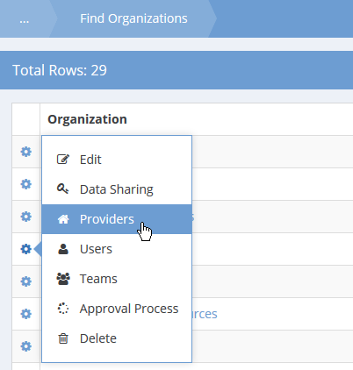

Next to the appropriate Organization, click the action gear and click Providers.

The Providers form displays a list of providers for the organization.

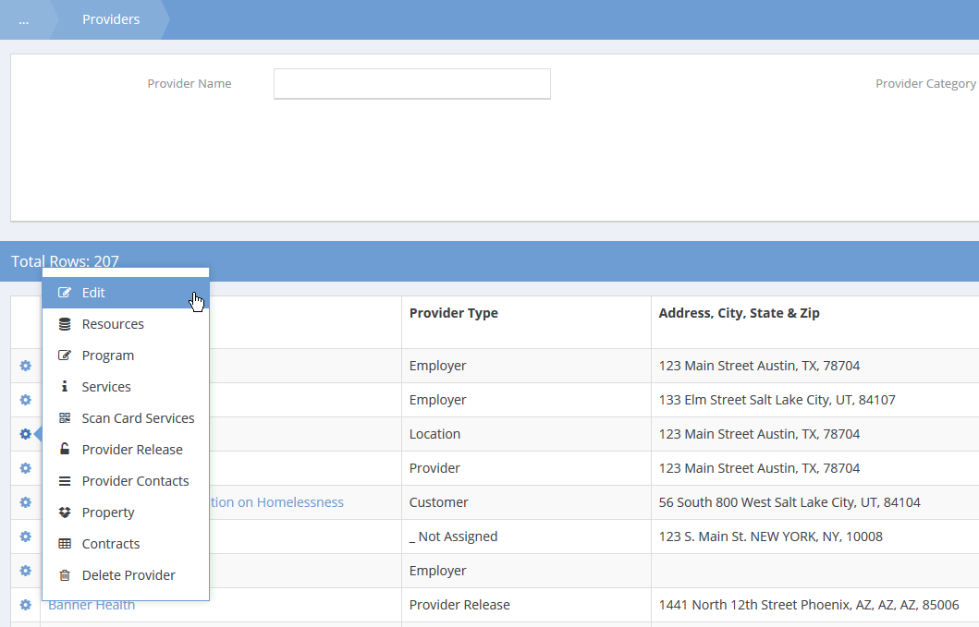

Next to the appropriate provider, click the action gear and click Edit. The Add/Edit Provider form displays.

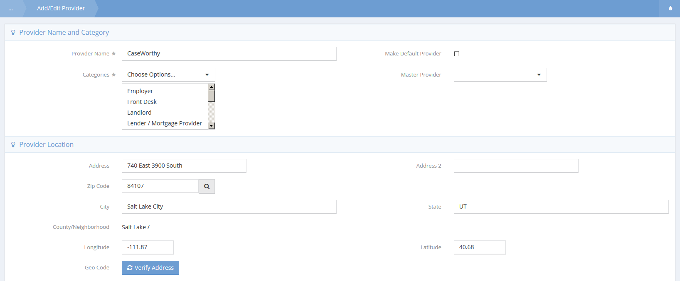

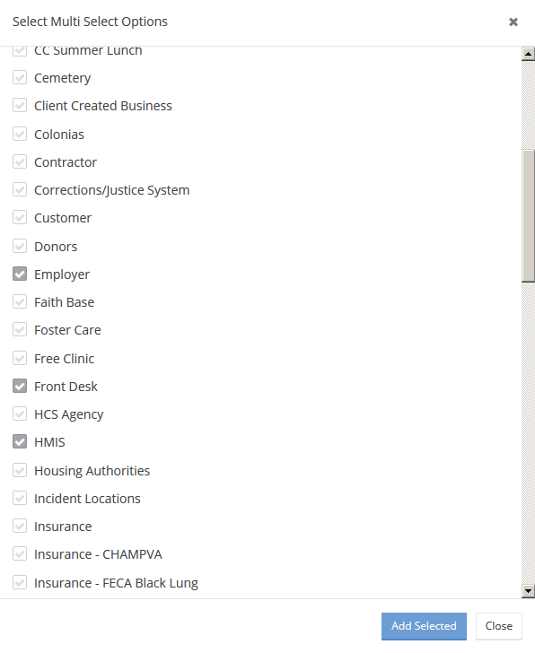

Select the drop down list in the Categories section, click the checkbox for HMIS, and click the button. The HMIS Data Elements section now appears.

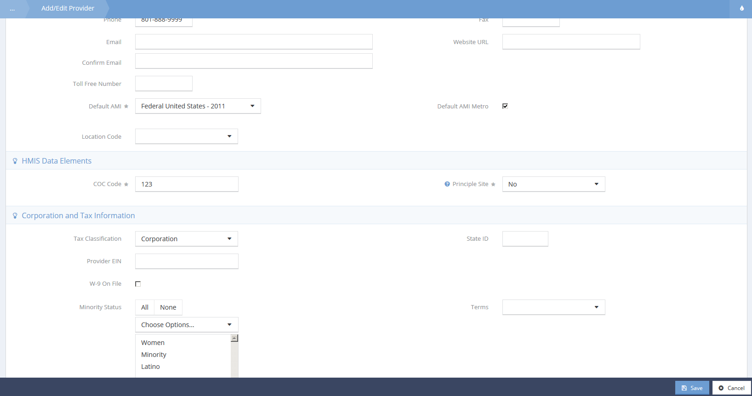

To set up HMIS information for Providers

Type or select the appropriate provider information for HMIS.

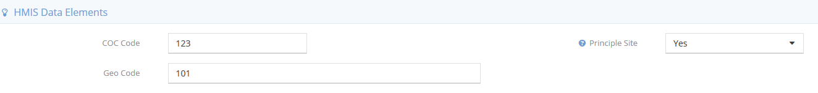

Selecting “Yes” for Principle Site makes the Geo Code field appear.

Program HMIS Set Up
Continue the HMIS HUD APR set up process by recording the appropriate Program information.
To access Program HMIS Setup
In the Administration tab, under Setup, click Programs/Accounts.

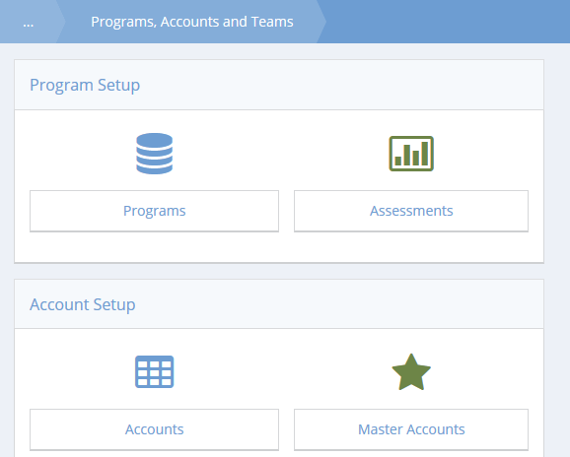

Click the Programs icon.

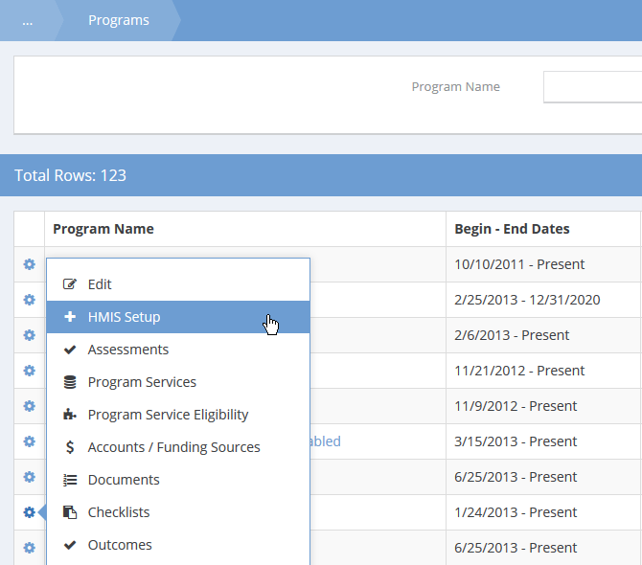

Next to the desired program, click the action gear and click HMIS Setup.

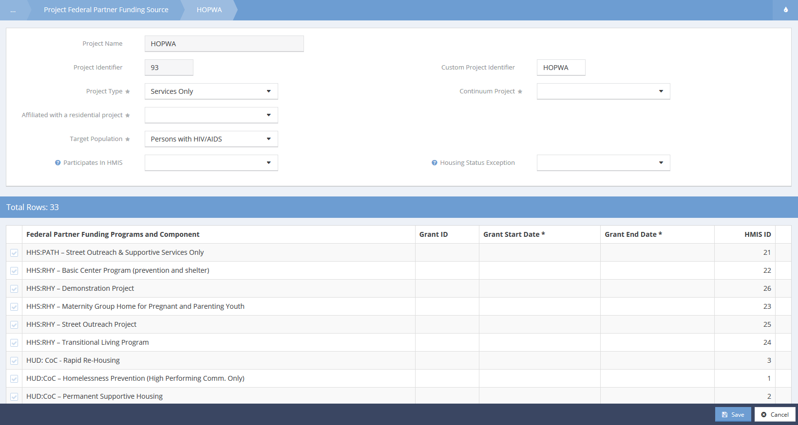

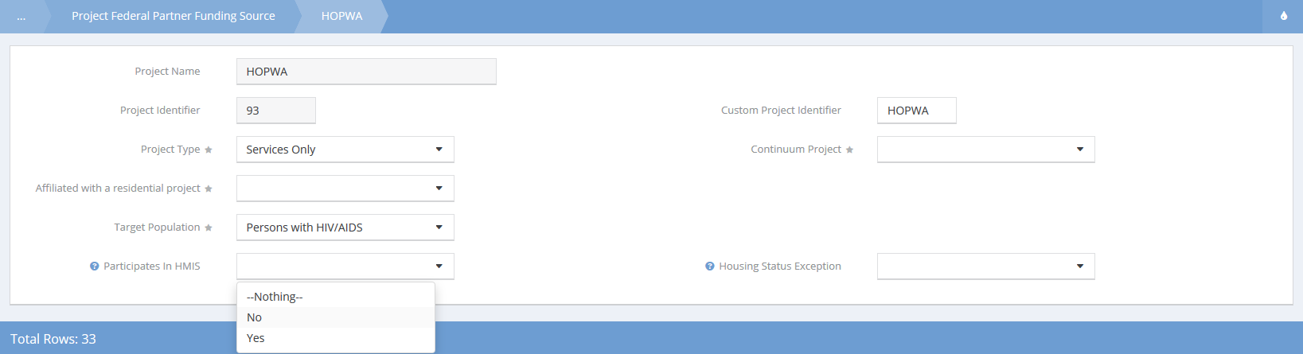

Type or select the appropriate Program information for HMIS. To map an HMIS participating program, click the drop down box for Participates in HMIS and click Yes. Two additional fields appear.

To complete program mapping, select a begin date and end date in the designated fields.

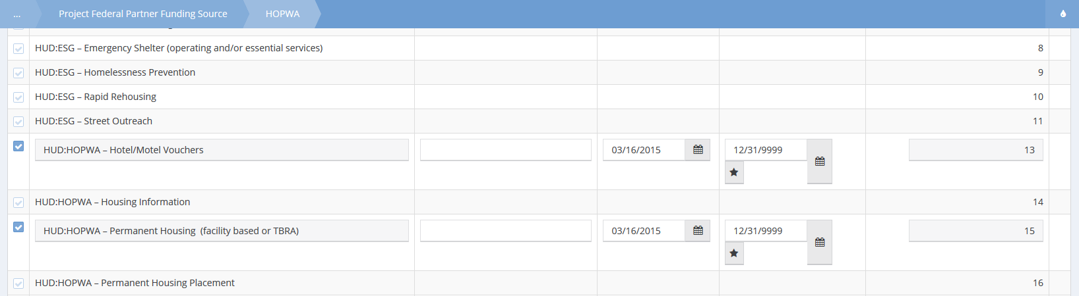

To select Federal Partner Funding Programs and Component, click the clear checkbox and select the date range. Click when done.

NOTE: You only have to set up this information once for all HMIS related reports.

Report Mapping
A number of compliance reports require services and issues be categorized into standard reporting categories. In order to produce a valid report you will need to use these functions to map the services and issues you use operationally to categorize them into standard reporting categories. Report mappings are defined in Administration>Setup>Mappings>Report Mapping.

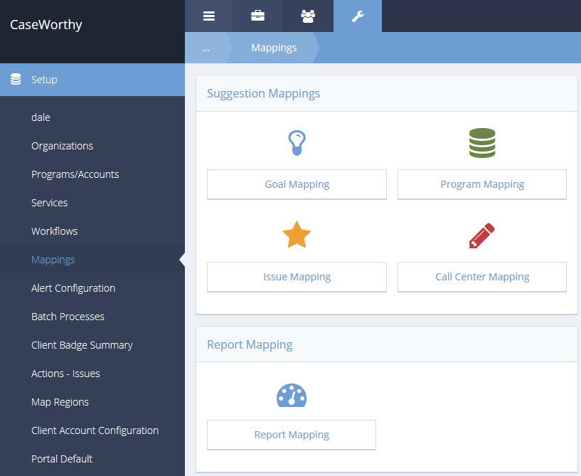

In order to produce a valid report you will need to use these functions to map the issues you use operationally to categorize them into standard reporting categories.

Map Services

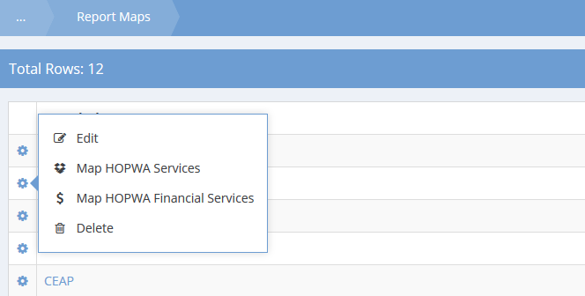

From Report Mapping, click the action gear for HOPWA and click Map HOPWA Services.

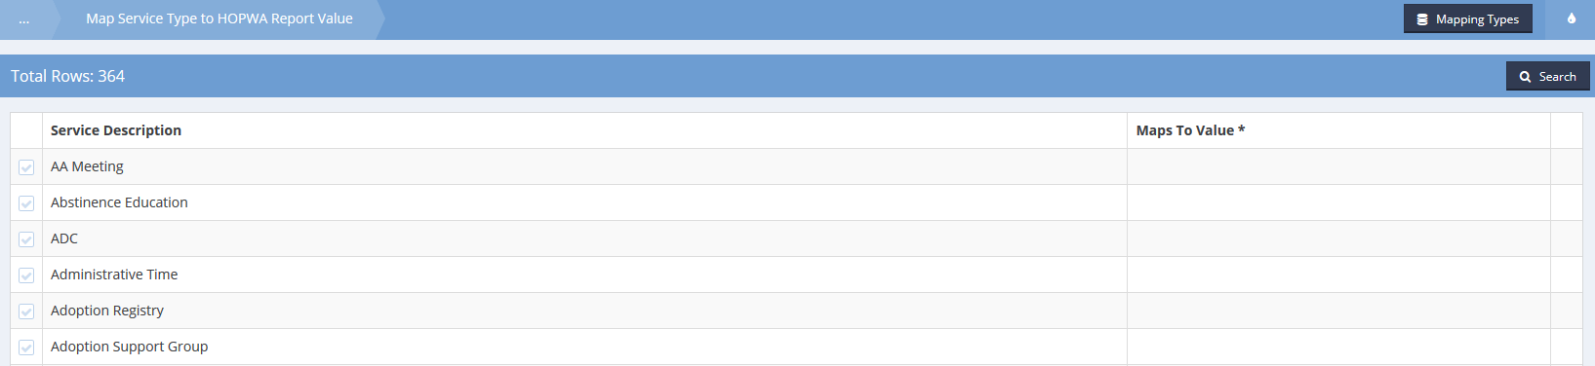

To edit mapping types, click .

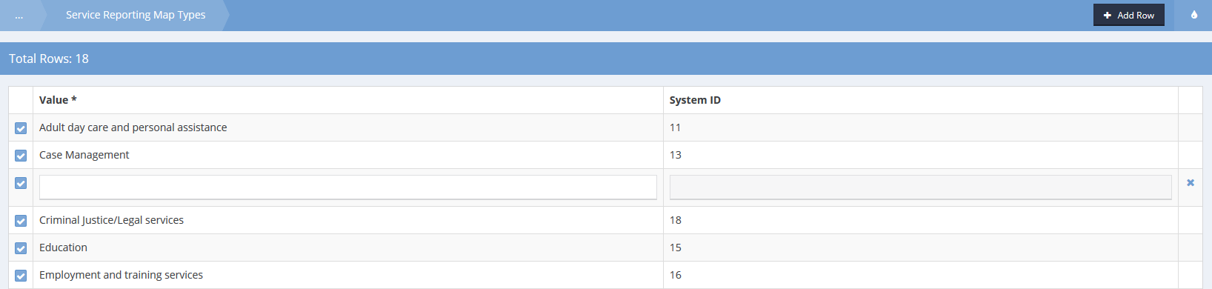

To add a new type click and enter a value. Click the icon to delete a type. Click to return to service mapping.

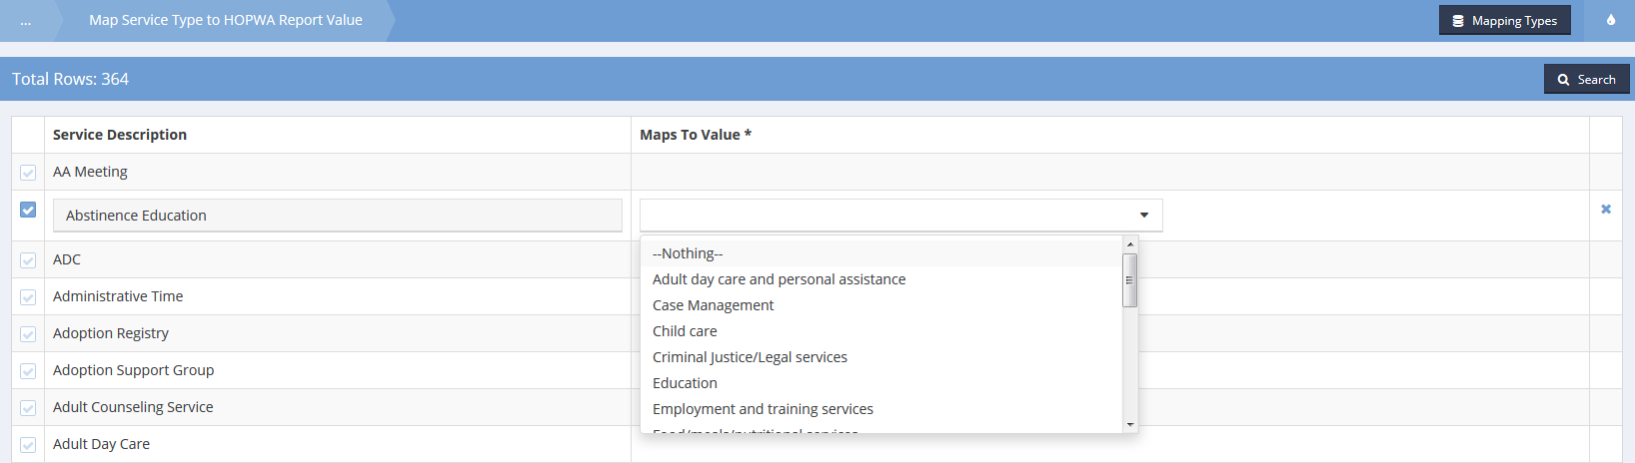

To map a service click the clear checkbox and select a value. Click when done.

Map Financial Services

From Report Mapping, click the action gear for HOPWA and click Map HOPWA Financial Services.

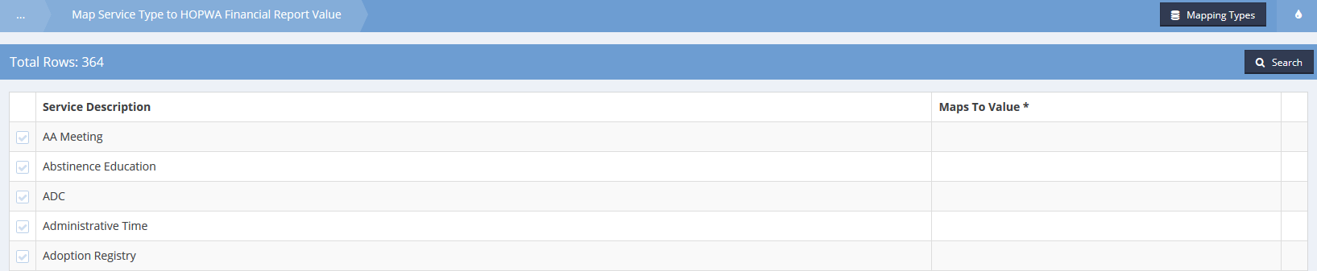

To edit mapping types, click .

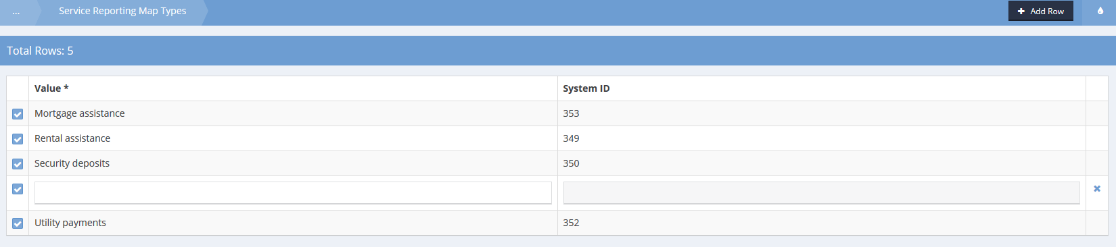

To add a new type click and enter a value. Click the icon to delete a type. Click to return to service mapping.

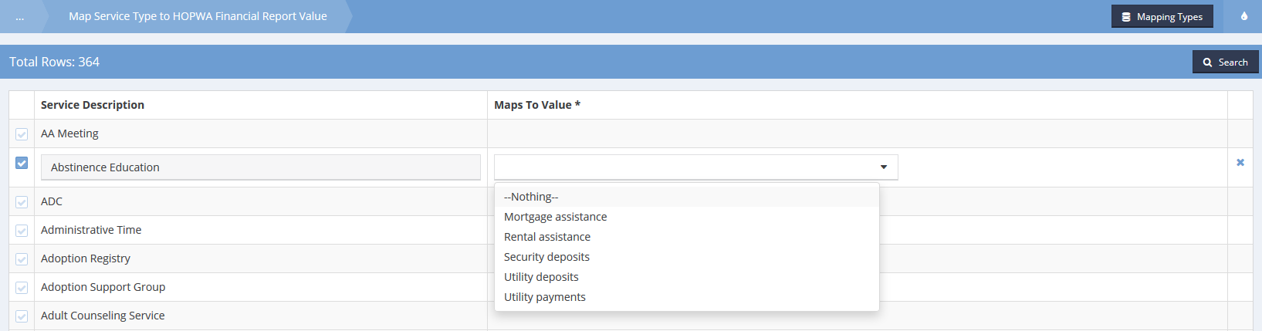

To map a service click the clear checkbox and select a value. Click when done.

Mapping HMIS Participating Programs
HMIS participating program mapping is now completed in program HMIS set up, which is covered in the previous section. Refer to it for HMIS program mappings.

Launching the Report

Report Launch page options
(Administration>Reporting>Compliance Reports)

To begin report set up, click the HOPWA icon.

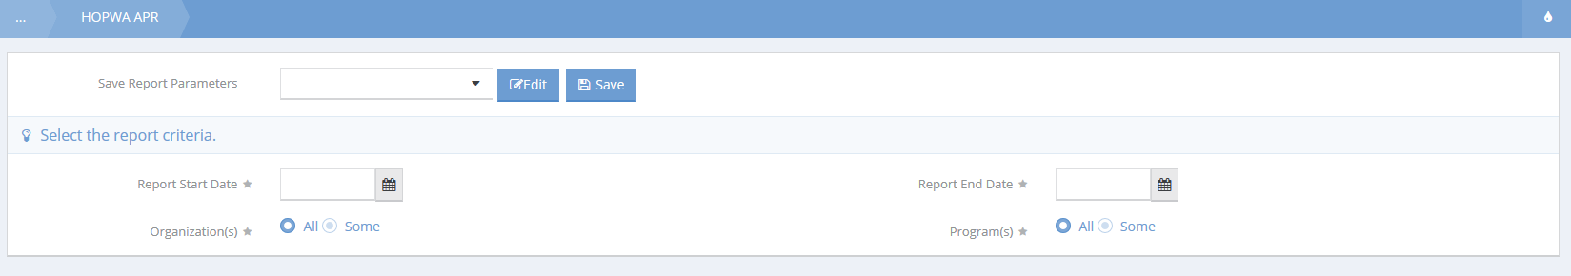

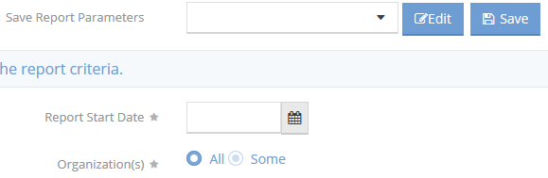
Enter a start date and select any organizations to be included in the report. Enter save parameters if desired.

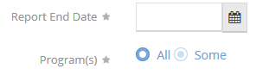
Enter an end date and select any programs to be included in the report.

Click the button and the report will launch.

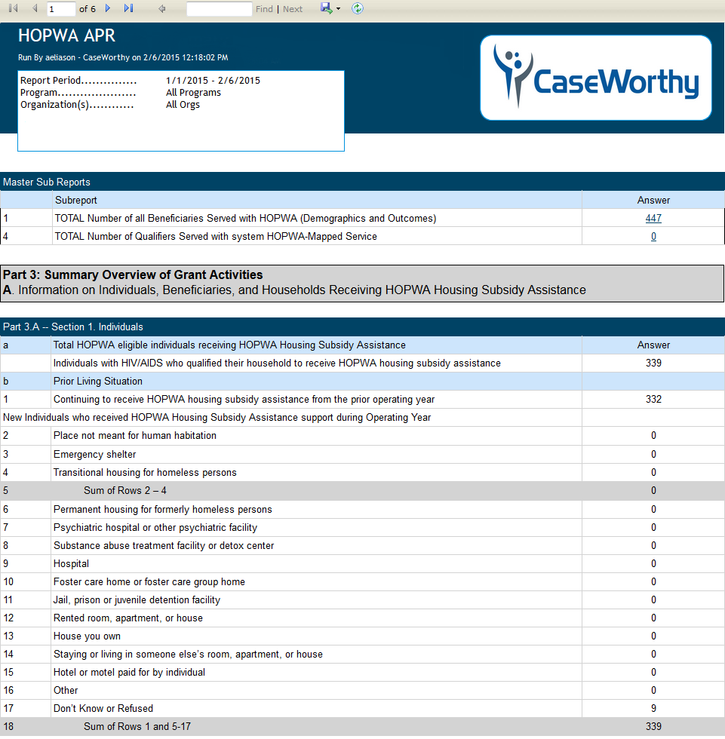

Report Navigation

Navigating the CaseWorthy™ baseline report

The Reports Tool Bar is located at the top of the report page just above the title.

Report pages can be selected by page number or the first page or last page can be selected.

A quick find is located in the reports tool bar to quickly identify specific data.

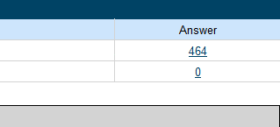
CaseWorthy™ provides details for most report totals. To view the details in a sub-report, click on the blue hyperlinked text.

To return to the main report from a sub report or drill down, click on the small, blue arrow located in the center of the report tool bar.

Reports can remain open while editing data. To refresh the data, click on the refresh icon.

Exporting Data

Export Icon
On the right-hand side of the tool bar is the export icon.

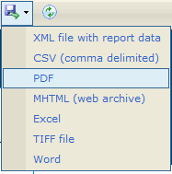
Clicking the export icon will display the available methods. Data may be exported to a number of different database, spreadsheet, and text file formats. CaseWorthy™ provides tools for exporting data to data sources including: XML files with report data, CVS (comma delimited), PDF, MHTML (web archive), Excel spreadsheets, TIFF file, and Word.

Excel Spreadsheet Export
Here’s an example of an Excel spreadsheet export with full report graphics for professional presentations:

