Revolutionizing Human Services Software

COC APR Reporting
Version 5.0● July 5, 2016

CaseWorthy, Inc.
3995 South 700 East
Suite 420
Salt Lake City, Utah
84107
Tel: 877-347-0877 Fax: 801-207-8350
Last edited: 05 July 2016
Copyright © 2010 CaseWorthy, Inc. All rights reserved.
No part of this publication may be reproduced, transmitted, transcribed, stored in a retrieval system, or translated into any language, in any form or by any means, electronic, mechanical, photocopying, recording, or otherwise, without prior written permission from CaseWorthy, Inc.
All copyright, confidential information, patents, design rights and all other intellectual property rights of whatsoever nature contained herein are and shall remain the sole and exclusive property of CaseWorthy, Inc. The information furnished herein is believed to be accurate and reliable.
However, no responsibility is assumed by CaseWorthy, Inc. for its use, or for any infringements of patents or other rights of third parties resulting from its use.
The CaseWorthy™ name and logo are trademarks or registered trademarks of CaseWorthy, Inc.
All other trademarks are the property of their respective owners.

Table of Contents
Introduction to CaseWorthy™ Reporting 2
About CaseWorthy™ Reporting 2
Locating the Reports Menu Group 2
Report Dashboard Introduction 2
Compliance Reports Menu 2
Key Terms 3
Definition of Key Terms 3
Report Specifications 3
Report Details 11
Report Set Up 22
Provider HMIS Set Up 22
To access the Provider HMIS Setup 22
To set up HMIS information for Providers 24
Program HMIS Set Up 24
To access Program HMIS Setup 24
Report Mapping 27
Mapping HMIS Participating Programs 28
Launching the Report 28
Report Launch page options 28
Report Navigation 31
Navigating the CaseWorthy™ baseline report 31
Exporting Data 32
Export Icon 32
Excel Spreadsheet Export 32

Introduction to CaseWorthy™ Reporting

About CaseWorthy™ Reporting
This User Guide provides agencies with specific requirements for generating reports for the Projects for Assistance in Transition from Homelessness program to enable organizations to effectively report out quantitative measures of HMIS APR.

Locating the Reports Menu Group
The CoC APR report is located on the Administration workspace. To access the Administration workspace, click the Administration icon in the upper-left portion of the screen. Once in the Administration tab, click the Reporting menu group located at the bottom of the taskbar list.
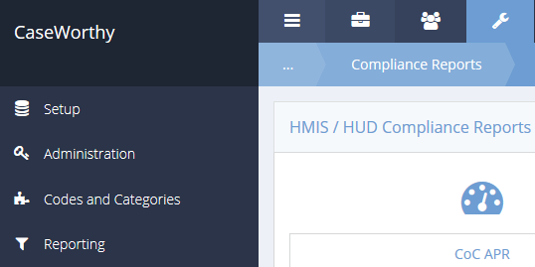

Report Dashboard Introduction
The CaseWorthy™ Reporting menu group is designed to assist agencies with their reporting needs. To ensure only authorized users can run and view reporting, the menu will only display for users with the level of Administrator. To allow users with less than an Administrator user level requires a custom role to be created and the menu item to be modified.

Compliance Reports Menu
When selecting the Compliance Reports menu group the system will display the Compliance Reports dashboard. Identify the icon labeled CoC APR and select it.

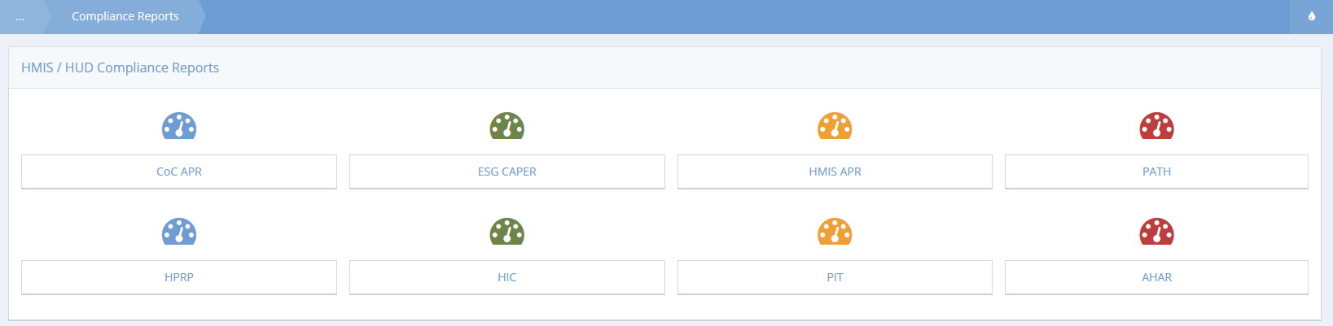

Key Terms

Definition of Key Terms

Leavers – persons who exited the project and are no longer enrolled in the project as of the last day of the reporting period.

Stayers - persons who are still enrolled in the project as of the last day of the reporting period, even if the person exited and re-entered at some point during the reporting period.

Report Specifications

The APR collects information on the people served during your operating year and on the types of households those people were in when they were last served. Some common elements run through the APR questions and are important to understand to interpret the information reported on the APR.
Most persons served by the project during the reporting period probably only had one project stay, meaning one project entry and/or exit during the reporting period. If a person had more than one project stay during the reporting period, data reported in this APR about that person is based on the person’s most recent project stay (i.e., their last stay of the reporting period).
Many questions report results separately for people served in different household configurations: persons in households without children, persons in households with at least one adult and one child, persons in households with only children, and persons whose household type is unknown. Each person’s household type is determined based on the persons in their household during the reporting period, using the person’s most recent project stay if they had more than one stay during the reporting period. (See Q8 for more information.)
Other questions report results separately for adults and children. Adult and child status is reported based on the person’s age on the day the individual entered the project or on the first day of the reporting period, whichever is later. If the person’s date of birth is not recorded in the HMIS, the person is to be recorded in the age unknown column.
Finally, some questions report data separately for leavers and stayers.

Data Quality

Total number of Clients – Enter the total number of persons served by this project in the period.

The term person (or client) served refers to all adults and children served by the project during the reporting period. This does not include caregivers who live with a disabled adult and children who are not in the care of a parent or guardian or not residing with them.

Street Outreach projects will only record the number of persons who have an “engagement date” recorded for their project stay.

Total number of Adults – Of the total number of persons served, enter the number of persons who are adults (i.e, age 18 or over). A person’s age is based on the project entry date closest to the end of the operating year. If a person entered the project prior to the start of the reporting period, the person’s age is based on the first day of the reporting period.

Total number of Unaccompanied Children – Of the total number of persons served, enter the number of persons who are unaccompanied children (i.e., age 17 or under in a household without anyone else).

Total number of Leavers – Of the total number of persons served, enter the number of Leavers (i.e., persons who exited during the reporting period and were not active in the project on the last day of the reporting period).

Data Quality - For each data element, specify the number of total persons in this project for whom the data element recorded in HMIS was “Client Doesn’t Know or Client Refused” and the number of persons with “Missing Data” (i.e., those for whom no information was recorded in the HMIS or was marked “Data Not Collected”).

Note that persons are not counted if the data element is not required to be collected. For example, children would not be counted in the veteran status data element.

Data quality is to be reported based on the latest enrollment for each client in the reporting period. Thus, the “total number of Clients” reported in the first part of this question will equal the total clients who were served including data entered for a client who may have been entered prior to the start of the reporting period.

VAWA providers should report data quality based on data provided in their comparable non-HMIS database. If multiple databases are used across a grant, the data is to be aggregated for reporting purposes.

Street Outreach projects missing data should only be counted for clients who have been identified as engaged in the project.

Persons Served

Consider all members of the household that were served within the reporting period when determining household type, regardless of whether they overlapped with one another.

Calculate each person’s age based on their most recent entry date within the reporting period or as of the first day of the reporting period, whichever is later.

Group all persons together who were in one household at any point in time in the reporting period.

Count as follows:
Households without Children – single adult persons or adults with adult companions that have never had a child in their household.
Households with Children and Adults – a person in any household with at least one adult and one child present regardless of whether the child(ren) is present for the full project stay. (Rule – If ever a child in the household, always a household with children).
Households with only Children – a person in any household in which all persons are younger than age 18.
Unknown Household Type – households that cannot be classified in cases when one or more persons are missing dates of birth. Note that in instances when the household already contains at least one known adult and one known child, the household type can be determined and categorized as a Household with Children and Adults.

Point-in-Time – Enter the count of persons by their household types on the last Wednesday of January, April, July, and October.

Households Served

Enter the total number of distinct households served during the full reporting period using the following rules:

1. For households in which each member has only one project stay during the reporting period, count one household and define the household type based on all members who were present during the reporting period.
2. For households in which one or more members have more than one project stay during the reporting period:
a. Consider all project stays in the reporting period chronologically.
b. If an identical group of people are served together on multiple project stays, count only one household.
c. If an adult who has been served previously in the reporting period re-enters the project later in the reporting period, then the adult and any persons served with him/her on both stays are counted as one household that may present in different configurations over time. Define the household type based on all members of the household who were served at any point during the reporting period.
d. If multiple adults were served earlier in the reporting period in two separate households in two separate stays, and subsequently are served together in a third stay, only two households are counted. Each of the two original households will be counted, because at the time of entry neither had adults who had been previously served. The third stay is not counted as a new household, because it contains adults who were previously served. To categorize the household type, join the household members from the later stay to the household that appeared earliest in the reporting period.

Unlike all other APR questions that are looking at the household configuration based on the person’s last stay during the operating year, the method of counting is different because this question is counting the total number of households – not the number of persons.
Within the reporting period, a household must only be counted as new if none of the adults in the household have been served before. If the household does not have an adult member, the group is to be considered a new household if the membership of the household differs from any prior project stay.
Point-in-Time - Enter the count of households by types served on the last Wednesday of January, April, July and October

Outreach Contacts and Engagement

Number of Persons Contacted During the Operating Year -Count the number of times, from the person’s first contact, that all people active in the project are contacted up until (and including) the date of engagement or the end of the operating year, whichever is earlier. Contacts made by persons who have open records during the operating year and whose entry date was prior to the start of the operating year are counted.

Enter the number of persons contacted within the number of times specified within each row, based on the location of person’s first contact (place not meant for human habitation, non-housing service site, at a housing location, or first contact place was missing).

Number of Persons Engaged (by the number of contacts they had) During the Operating Year – Enter the total number of persons engaged during the operating year (reporting period), recording people in the row associated with the number of contacts made prior to engagement and in the column of each person’s first contact.

Rate of Engagement -The rate of engagement is an automatic calculation. It calculates how many contacts it took for all clients who were engaged during the reporting period to become engaged.

Age

The age question divides all persons served in the reporting period into age groups. Age must be reported based on the person’s age at most recent project entry (the last project stay of the reporting period) or on the first day of the reporting period, whichever is later. Report the number of persons served within each age group based on each person’s age and household type.

Physical and Mental Health Conditions

These questions identify the reported conditions/disabilities of all persons served by the project during the reporting period. These include: mental illness, alcohol abuse, drug abuse, chronic health condition, HIV/AIDS and related diseases, developmental disability, and physical disability. The information on conditions are to be based on latest project entry.

Domestic Violence Experience

Q19a reports only on adults and unaccompanied children who indicated they were victims of domestic violence served by the project during the reporting period, as reported at the time of their last project entry of the year. Children in households of adult victims are not reported, nor are children in households comprised only of multiple minors.

Physical and Mental Health Conditions at Exit

These questions identify the reported physical and mental health conditions of all persons served by the project during the reporting period based on what was recorded on their last exit from the project during the reporting period. If a person has not exited the project they are considered a stayer and their information must be taken from the assessment nearest to the end of the reporting period, even if that is the project entry data. Conditions to be reported include: mental illness, alcohol abuse, drug abuse, chronic health condition, HIV/AIDS and related diseases, developmental disability, and physical disability. If the data indicates that a “disabling condition” was present but does not specify which condition it is, then that person is counted under “Condition Unknown.”

Cash Income Range – Income Amount

Q23 reports on total cash income for all adults in the project by entry and either the latest follow-up for stayers or at exit for leavers. To be reported as having income the client record in HMIS must have a total monthly income reported at $0.00 or more. Records that only recorded a source of income and did not include the total monthly income dollar value will be shown as “Information Missing.”

Client Cash Income Category – Income Category – by Entry and Follow-up/Exit Status

Differentiating earned (i.e., employment) income from other income is important for HUD’s required reporting to Congress. Q24a reports on the number of adults the project had at project entry, at the time of their annual assessment or follow-up for stayers, and at the time of exit for leavers based on income type. The categories are:
- Earned Income = all adults with income over $0.00 from earned (employment) income.
- Other Income = all adults with income over $0.00 from all sources, except earned income, including: Unemployment Insurance, SSI, SSDI, Veteran’s Disability, Private Disability Insurance, Worker’s Compensation, TANF (or the equivalent of), General Assistance, Retirement (Social Security), Veteran’s Pension, Pension from a Former Job, Child Support, Alimony/Spousal Support, and Other.
- Both Earned and Other Income = all adults with income over $0.00 in both earned income and another source of income. (Note: adults counted in this category are NOT counted in the categories above.)
- No Income = all adults with $0.00 recorded for income.
- Don’t Know/Refused Income = adults with either Client doesn’t know or Client refused as the response to Income from any source and no dollar amount recorded in income.
- Missing Income = all adults without a response to Income from any source and no dollar amount in income recorded in HMIS; for stayers, all adults whose length of stay in the project was greater than 365 days and had no income assessment recorded in HMIS subsequent to project entry.
- Total Adults = all adults in the project during the operating year with either earned income, other income, both earned and other income, no income, don’t know their income, refused to tell the provider their income or missing income.
- Adults with Income Information at Entry and Follow-Up or Exit = this row reports adults who have a definite known income (equal to or more than $0.00) at both project entry and either follow-up (for stayers) or exit (for leavers).

Client Cash Income Change

Q24b builds off of the information reported on Q24a. The Q24b series of questions reports in greater detail across income categories on the change of income for those adults with recorded income (including $0.00) at entry and at either follow-up (stayers), at exit (leavers) or both. Clients with Don’t know, Client refused, or Missing income information are not included. Q24b has three tables:
- Q24b1 – Income Sources by Entry and Latest Status – reports on adult stayers
- Q24b2 – Income Sources by Entry and Exit – reports on adult leavers

- Q24b3 – Income Sources by Entry and Latest Status or Exit – reports on adult stayers and leavers
This time the question categorizes the adults in the project by:
- Earned income
  - Counting the number of adults with recorded earned income
  - Reporting the average dollar amount change in the earned income
- Other Income
  - Counting the number of adults with recorded other income
  - Reporting the average dollar amount change in other income
- Any income (i.e., the income could have been from employment or other or both)
  - Counting the number of adults with any recorded income
  - Reporting the average dollar amount change in total income

Cash Income (Sources and Number of Sources)

Q25 reports income sources separately for adults, children, or persons of unknown age. The HMIS Data Standards instruct that income must be collected for each person served by a project. Any income associated with a member of a household is to be assigned to that person; however, income may be assigned to a head of household if an amount cannot be attributed to a specific member of the household. As a general rule, the income and income source are assigned to the person who is receiving the income (generally who is named on the check). For example, if a parent is employed, the employment source is marked for the employed parent; if a TANF check is received, the income source is marked under the parent’s name; if a social security check is received for a child, it would be recorded under that child’s record.

Non-cash Benefits (Sources and Number of Sources)

Q26 reports information on the type and number of non-cash benefit sources reported for adults, children, and persons with unknown age. Responses are reported separately for leavers and stayers. Unlike cash income sources, according to HMIS Data Standards, benefits are recorded for all persons for whom the benefit was intended. For example, if a family receives food stamps for the entire family, then each family member must have food stamps recorded as a non-cash benefit source for them.

Length of Participation

This question identifies the length of participation of persons served in the project based on their last episode of service/housing in the project. Participation accounts for all the days a person was in the project – even if some of those days occurred prior to the reporting period. For leavers, count the days from intake to the date of exit. For stayers, count the days from intake until the last day of the reporting period. The average and median days for both leavers and stayers is also reported.

Report Details

7.a Number of persons Served During Operating Year
1 | Total number of applicable records for All Clients | Enrollment members
2 | Total number of applicable records for Adults | >= 18
3 | Total number of applicable records for Unaccompanied Youth | <18 with household size of "1"
4 | Total number of applicable records for Leavers | Enrollment.exitdate within reporting period

7.b Data quality of persons Served During Operating Year
1 | Data Element | Don t Know or Refused | Missing Data
2 | First Name Client.FirstName | N/A | Null
3 | Last Name Client.LastName | N/A | Null
4 | SSN Client.SSN | 3, 4 | Null
5 | Date of Birth Client.Birthdate | 3, 4 | Null
6 | Race Client.Race | 8, 9 | Null
7 | Ethnicity Client.Ethnicity | 8, 9 | Null
8 | Gender Client.Gender | 6, 7 | Null
9 | Veteran Status Client.VeteranStatus | 3, 4 | Null
10 | Disabling Condition AssessHUDUnv.Disabled | 3, 4 | Null
 | Residence Prior to Entry PriorResidence | 20, 21 | Null
 | Zip of Last Permanent Address PriorZipCode | N/A | N/A
 | Housing Status (at entry) HousingStatus | N/A | N/A
 | Income (at entry) EntryHUD30DayIncomeQuality | 3, 4 | Null
 | Non-Cash Benefits (at entry) EntryNonCashBenefit | 3, 4 | Null
11 | Non-Cash Benefits (at exit) LatestNonCashBenefit | 3, 4 | Null
12 | Physical Disability (at entry) PhysicalDisability | 3, 4 | Null
13 | Developmental Disability (at entry) DevelopmentalDisabled | 3, 4 | Null
14 | Chronic Health Condition (at entry) ChronicIllness | 3, 4 | Null
15 | HIV/AIDS (at entry) HIVAidsStatus | 3, 4 | Null
16 | Mental Health (at entry) MentalIllness | 3, 4 | Null
17 | Substance Abuse (at entry) SubstanceAbuse | 8, 9 | Null
18 | Domestic Violence (at entry) DomesticViolence | 3, 4 | Null
19 | Destination ExitDestination | 8, 9 | Null

8a. Number of Persons Served During the Operating Year
Label | Total | W/O Children | Children & Adults | Children only | Unknown Type
[Label] | Total | WithoutChildren | WithChildrenAndAdults | WithOnlyChildren | UnknownType
Total

8b. Average Number of Persons Served Each Night
Label | Total | W/O Children | Children & Adults | Children only | Unknown Type
[Label] | Total | WithoutChildren | WithChildrenAndAdults | WithOnlyChildren | UnknownType
Total

8c. Point-in-Time Count of Persons Served on the Last Wednesday in
Label | Total | W/O Children | Children & Adults | Children only | Unknown Type
[Label] | Total | WithoutChildren | WithChildrenAndAdults | WithOnlyChildren | UnknownType
Total

9a. Number of Households Served During the Operating Year
Label | Total | W/O Children | Children & Adults | Children only | Unknown Type
[Label] | Total | WithoutChildren | WithChildrenAndAdults | WithOnlyChildren | UnknownType
Total

9b. Point-in-Time Count of Households Served on the Last Wednesday in
Label | Total | W/O Children | Children & Adults | Children only | Unknown Type
[Label] | Total | WithoutChildren | WithChildrenAndAdults | WithOnlyChildren | UnknownType
Total

15.a Gender - Adults
Label | Total | W/O Children | Children & Adults | Children only | Unknown Type
[Label] | Total | WithoutChildren | WithChildrenAndAdults | WithOnlyChildren | UnknownType
Total

15.b Gender - Children
Label | Total | W/O Children | Children & Adults | Children only | Unknown Type
[Label] | Total | WithoutChildren | WithChildrenAndAdults | WithOnlyChildren | UnknownType
Total

15.c Gender – Missing Age
Label | Total | W/O Children | Children & Adults | Children only | Unknown Type
[Label] | Total | WithoutChildren | WithChildrenAndAdults | WithOnlyChildren | UnknownType
Total

16 Age
Label | Total | W/O Children | Children & Adults | Children only | Unknown Type
[Label] | Total | WithoutChildren | WithChildrenAndAdults | WithOnlyChildren | UnknownType
Total

17.a Ethnicity
Label | Total | W/O Children | Children & Adults | Children only | Unknown Type
[Label] | Total | WithoutChildren | WithChildrenAndAdults | WithOnlyChildren | UnknownType
Total

17.b Race
Label | Total | W/O Children | Children & Adults | Children only | Unknown Type
[Label] | Total | WithoutChildren | WithChildrenAndAdults | WithOnlyChildren | UnknownType
Total

18.a. Physical and Mental Conditions
Condition | Total | W/O Children | Children & Adults | Children only | UnknownType
Mental Illness | MentalIllness = 1
Alcohol Abuse | SubstanceAbuse = 3, 5
Drug Abuse | SubstanceAbuse = 4, 5
Chronic Health Condition | ChronicIllness = 1
HIV/AIDS and Related Diseases | HIVAidsStatus = 1
Developmental Disability | DevelopmentalDisabled = 1
Physical Disability | PhysicalDisability = 1
Total

18.b. Number of Conditions
Label | Total | W/O Children | Children & Adults | Children only | Unknown Type
None | NumConditions = 0 AND DisablingCondition = 2
1 Condition | NumConditions = 1
2 Conditions | NumConditions = 2
3+ Conditions | NumConditions >= 3
Disabled - Unknown | NumConditions = 0 and DisablingCondition = 1
Don't Know/Refused | DisablingCondition = 3 or DisablingCondition = 4
Information Missing | NumConditions = 0 and DisablingCondition is nothing or 99
Total

19.a Past Domestic Violence Experience
Label | Total | W/O Children | Children & Adults | Children only | Unknown Type
[Label] | Total | WithoutChildren | WithChildrenAndAdults | WithOnlyChildren | UnknownType
Total

19.b When Past Domestic Violence Occurred
Label | Total | W/O Children | Children & Adults | Children only | Unknown Type
[Label] | Total | WithoutChildren | WithChildrenAndAdults | WithOnlyChildren | UnknownType
Total

20.a Residence Prior to Program Entry – Homeless Situations
Label | Total | W/O Children | Children & Adults | Children only | Unknown Type
[Label] | Total | WithoutChildren | WithChildrenAndAdults | WithOnlyChildren | UnknownType
Total

20.b Residence Prior to Program Entry – Institutional Settings
Label | Total | W/O Children | Children & Adults | Children only | Unknown Type
[Label] | Total | WithoutChildren | WithChildrenAndAdults | WithOnlyChildren | UnknownType
Total

20.c Residence Prior to Program Entry – Other Locations
Label | Total | W/O Children | Children & Adults | Children only | Unknown Type
[Label] | Total | WithoutChildren | WithChildrenAndAdults | WithOnlyChildren | UnknownType
Total

21 Veteran Status
Label | Total | W/O Children | Children & Adults | Children only | Unknown Type
[Label] | Total | WithoutChildren | WithChildrenAndAdults | WithOnlyChildren | UnknownType
Total

22.a1 Physical and Mental Issues of “leavers”
Condition | Total | Adults | Children | Age Unknown
Mental Illness | MentalIllness = 1
Alcohol Abuse | SubstanceAbuse = 3, 5
Drug Abuse | SubstanceAbuse = 4, 5
Chronic Health Condition | ChronicIllness = 1
HIV/AIDS and Related Diseases | HIVAidsStatus = 1
Developmental Disability | DevelopmentalDisabled = 1
Physical Disability | PhysicalDisability = 1

22.a2 Number of Physical and Mental Conditions of “leavers”
Condition | Total | Adults | Children | Age Unknown
None | NumConditions = 0 AND DisablingCondition = 2
1 Condition | NumConditions = 1
2 Conditions | NumConditions = 2
3+ Conditions | NumConditions >= 3
Condition Unknown | NumConditions = 0 and DisablingCondition = 1
Don’t Know Refused | DisablingCondition = 3 or DisablingCondition = 4
Information Missing | NumConditions = 0 and DisablingCondition is nothing or 99

22.b1 Physical and Mental Issues of “stayers”
Condition | Total | Adults | Children | Age Unknown
Mental Illness | MentalIllness = 1
Alcohol Abuse | SubstanceAbuse = 3, 5
Drug Abuse | SubstanceAbuse = 4, 5
Chronic Health Condition | ChronicIllness = 1
HIV/AIDS and Related Diseases | HIVAidsStatus = 1
Developmental Disability | DevelopmentalDisabled = 1
Physical Disability | PhysicalDisability = 1

22.b2 Number of Physical and Mental Conditions of “stayers”
Condition | Total | Adults | Children | Age Unknown
None | NumConditions = 0 AND DisablingCondition = 2
1 Condition | NumConditions = 1
2 Conditions | NumConditions = 2
3+ Conditions | NumConditions >= 3
Condition Unknown | NumConditions = 0 and DisablingCondition = 1
Don’t Know Refused | DisablingCondition = 3 or DisablingCondition = 4
Information Missing | NumConditions = 0 and DisablingCondition is nothing or 99

23 Client Cash Income Range
Label | Income at Entry | Income at Latest Followup (Stayers) | Income at Exit (Leavers)
No Income | EntryTotalIncome = 0
1-150 | EntryTotalIncome > 0 and <= 150
151-250 | EntryTotalIncome > 150 and <= 250
501-1000 | EntryTotalIncome > 500 and <= 1000
1001-1500 | EntryTotalIncome > 1000 and <= 1500
1501-2000 | EntryTotalIncome > 1500 and <= 2000
2001+ | EntryTotalIncome > 2000
Don’t Know / Refused
Information Missing | Is nothing
Total Adults

24 A Client Cash Income Category – Income Category – by Entry and Follow-up/Exit Status
Label | Adults at Entry | Adults at Followup (Stayers) | Adults at Exit (Leavers)
Adults with Only Earned income | EntryFinancialCategory = 1 | LatestFinancialCategory = 1 | LatestFinancialCategory = 1
Adults with Only Other Income | EntryFinancialCategory = 2 | LatestFinancialCategory = 2 | LatestFinancialCategory = 2
Adults with Both Earned Income and Other Income | EntryFinancialCategory = 3 | LatestFinancialCategory = 3 | LatestFinancialCategory = 3
Adults with No Income | EntryFinancialCategory = 8 | LatestFinancialCategory = 8 | LatestFinancialCategory = 8
Adults with Don’t Know / Refused Income Information
Adults with Missing Income Information | EntryFinancialCategory = 9 | LatestFinancialCategory = 9 | LatestFinancialCategory = 9
Total Adults
Adults with Income Information at Entry and Follow-up/Exit |  | EntryFinancialCategory and LatestFinancialCategory <> 9 | EntryFinancialCategory and LatestFinancialCategory <> 9

24 B1 Client Cash Income Change – Income Source – by Entry and Latest Status
24.b 1 Income Change by Income Category (Universe: Adults Stayers with Income Information at Entry and Follow-up) | Had Income Category at Entry and Did Not Have it at Follow-up | Retained Income Category But Had Less $ at Follow-up Than at Entry | Retained Income Category and Same $ at Follow-up as at Entry |  | Retained Income Category and Increased $ at Follow-up | Did Not Have the Income Category at Entry and Gained the Income Category at Follow-up | Did Not Have the Income Category at Entry or at Follow-up | Total Adults (including those with no income)
Number of Adults with Earned Income | EntryEarnedIncome > 0 and LatestEarnedIncome = 0 | EntryEarnedIncome > 0 and LatestEarnedIncome > 0 and EntryEarnedIncome > LatestEarnedIncome | EntryEarnedIncome > 0 and LatestEarnedIncome > 0 and EntryEarnedIncome = LatestEarnedIncome | EntryEarnedIncome > 0 and LatestEarnedIncome > 0 and EntryEarnedIncome < LatestEarnedIncome |  | EntryEarnedIncome = 0 and LatestEarnedIncome > 0 | EntryEarnedIncome = 0 and LatestEarnedIncome = 0
Average change in Earned Income | LatestEarnedIncome - EntryEarnedIncome | LatestEarnedIncome - EntryEarnedIncome |  | LatestEarnedIncome - EntryEarnedIncome |  | LatestEarnedIncome - EntryEarnedIncome
Number of Adults with Other Income | EntryOtherIncome > 0 and LatestOtherIncome = 0 | EntryOtherIncome > 0 and LatestOtherIncome > 0 and EntryOtherIncome > LatestOtherIncome | EntryOtherIncome > 0 and LatestOtherIncome > 0 and EntryOtherIncome = LatestOtherIncome | EntryOtherIncome > 0 and LatestOtherIncome > 0 and EntryOtherIncome < LatestOtherIncome |  | EntryOtherIncome = 0 and LatestOtherIncome > 0 | EntryOtherIncome = 0 and LatestOtherIncome = 0
Average change in Other Income | LatestOtherIncome - EntryOtherIncome | LatestOtherIncome - EntryOtherIncome |  | LatestOtherIncome - EntryOtherIncome |  | LatestOtherIncome - EntryOtherIncome
Number of Adults Any Income | EntryTotalIncome > 0 and LatestTotalIncome = 0 | EntryTotalIncome > 0 and LatestTotalIncome > 0 and EntryTotalIncome > LatestTotalIncome | EntryTotalIncome > 0 and LatestTotalIncome > 0 and EntryTotalIncome = LatestTotalIncome | EntryTotalIncome > 0 and LatestTotalIncome > 0 and EntryTotalIncome < LatestTotalIncome |  | EntryTotalIncome = 0 and LatestTotalIncome > 0 | EntryTotalIncome = 0 and LatestTotalIncome = 0
Average Change in Overall Income | LatestTotalIncome - EntryTotalIncome | LatestTotalIncome - EntryTotalIncome |  | LatestTotalIncome - EntryTotalIncome |  | LatestTotalIncome - EntryTotalIncome |  | LatestTotalIncome - EntryTotalIncome

24 B2 Client Cash Income Change – Income Source – by Entry and Latest Status
24.b 2 Income Change by Income Category (Universe: Adults Leavers with Income Information at Entry and Follow-up) | Had Income Category at Entry and Did Not Have it at Follow-up | Retained Income Category But Had Less $ at Follow-up Than at Entry | Retained Income Category and Same $ at Follow-up as at Entry | Retained Income Category and Increased $ at Follow-up | Did Not Have the Income Category at Entry and Gained the Income Category at Follow-up | Did Not Have the Income Category at Entry or at Follow-up | Total Adults (including those with no income)
Number of Adults with Earned Income | EntryEarnedIncome > 0 and LatestEarnedIncome = 0 | EntryEarnedIncome > 0 and LatestEarnedIncome > 0 and EntryEarnedIncome > LatestEarnedIncome | EntryEarnedIncome > 0 and LatestEarnedIncome > 0 and EntryEarnedIncome = LatestEarnedIncome | EntryEarnedIncome > 0 and LatestEarnedIncome > 0 and EntryEarnedIncome < LatestEarnedIncome | EntryEarnedIncome = 0 and LatestEarnedIncome > 0 | EntryEarnedIncome = 0 and LatestEarnedIncome = 0
Average change in Earned Income | LatestEarnedIncome - EntryEarnedIncome | LatestEarnedIncome - EntryEarnedIncome |  | LatestEarnedIncome - EntryEarnedIncome | LatestEarnedIncome - EntryEarnedIncome
Number of Adults with Other Income | EntryOtherIncome > 0 and LatestOtherIncome = 0 | EntryOtherIncome > 0 and LatestOtherIncome > 0 and EntryOtherIncome > LatestOtherIncome | EntryOtherIncome > 0 and LatestOtherIncome > 0 and EntryOtherIncome = LatestOtherIncome | EntryOtherIncome > 0 and LatestOtherIncome > 0 and EntryOtherIncome < LatestOtherIncome | EntryOtherIncome = 0 and LatestOtherIncome > 0 | EntryOtherIncome = 0 and LatestOtherIncome = 0
Average change in Other Income | LatestOtherIncome - EntryOtherIncome | LatestOtherIncome - EntryOtherIncome |  | LatestOtherIncome - EntryOtherIncome | LatestOtherIncome - EntryOtherIncome
Number of Adults Any Income | EntryTotalIncome > 0 and LatestTotalIncome = 0 | EntryTotalIncome > 0 and LatestTotalIncome > 0 and EntryTotalIncome > LatestTotalIncome | EntryTotalIncome > 0 and LatestTotalIncome > 0 and EntryTotalIncome = LatestTotalIncome | EntryTotalIncome > 0 and LatestTotalIncome > 0 and EntryTotalIncome < LatestTotalIncome | EntryTotalIncome = 0 and LatestTotalIncome > 0 | EntryTotalIncome = 0 and LatestTotalIncome = 0
Average Change in Overall Income | LatestTotalIncome - EntryTotalIncome | LatestTotalIncome - EntryTotalIncome |  | LatestTotalIncome - EntryTotalIncome | LatestTotalIncome - EntryTotalIncome |  | LatestTotalIncome - EntryTotalIncome

24 B3 Client Cash Income Change – Income Source – by Entry and Latest Status
24.b 3 Income change by Income Category (Universe: Total adults with Income Information at Entry and either Follow-up (Stayers) or Exit (Leavers) | Had Income Category at Entry and Did Not Have it at Follow-up | Retained Income Category But Had Less $ at Follow-up Than at Entry | Retained Income Category and Same $ at Follow-up as at Entry | Retained Income Category and Increased $ at Follow-up | Did Not Have the Income Category at Entry and Gained the Income Category at Follow-up | Did Not Have the Income Category at Entry or at Follow-up | Total Adults (including those with no income)
Number of Adults with Earned Income | EntryEarnedIncome > 0 and LatestEarnedIncome = 0 | EntryEarnedIncome > 0 and LatestEarnedIncome > 0 and EntryEarnedIncome > LatestEarnedIncome | EntryEarnedIncome > 0 and LatestEarnedIncome > 0 and EntryEarnedIncome = LatestEarnedIncome | EntryEarnedIncome > 0 and LatestEarnedIncome > 0 and EntryEarnedIncome < LatestEarnedIncome | EntryEarnedIncome = 0 and LatestEarnedIncome > 0 | EntryEarnedIncome = 0 and LatestEarnedIncome = 0
Average change in Earned Income | LatestEarnedIncome - EntryEarnedIncome | LatestEarnedIncome - EntryEarnedIncome |  | LatestEarnedIncome - EntryEarnedIncome | LatestEarnedIncome - EntryEarnedIncome
Number of Adults with Other Income | EntryOtherIncome > 0 and LatestOtherIncome = 0 | EntryOtherIncome > 0 and LatestOtherIncome > 0 and EntryOtherIncome > LatestOtherIncome | EntryOtherIncome > 0 and LatestOtherIncome > 0 and EntryOtherIncome = LatestOtherIncome | EntryOtherIncome > 0 and LatestOtherIncome > 0 and EntryOtherIncome < LatestOtherIncome | EntryOtherIncome = 0 and LatestOtherIncome > 0 | EntryOtherIncome = 0 and LatestOtherIncome = 0
Average change in Other Income | LatestOtherIncome - EntryOtherIncome | LatestOtherIncome - EntryOtherIncome |  | LatestOtherIncome - EntryOtherIncome | LatestOtherIncome - EntryOtherIncome
Number of Adults Any Income | EntryTotalIncome > 0 and LatestTotalIncome = 0 | EntryTotalIncome > 0 and LatestTotalIncome > 0 and EntryTotalIncome > LatestTotalIncome | EntryTotalIncome > 0 and LatestTotalIncome > 0 and EntryTotalIncome = LatestTotalIncome | EntryTotalIncome > 0 and LatestTotalIncome > 0 and EntryTotalIncome < LatestTotalIncome | EntryTotalIncome = 0 and LatestTotalIncome > 0 | EntryTotalIncome = 0 and LatestTotalIncome = 0
Average Change in Overall Income | LatestTotalIncome - EntryTotalIncome | LatestTotalIncome - EntryTotalIncome |  | LatestTotalIncome - EntryTotalIncome | LatestTotalIncome - EntryTotalIncome |  | LatestTotalIncome - EntryTotalIncome

25.a1 Cash Income Sources for “leavers”
Label | Total | Adults | Children | Age Unknown
[Label] | Total | Adults | Children | AgeUnknown
Total

25.a2 Number of Cash Income Sources for “leavers”
Label | Total | Adults | Children | Age Unknown
[Label] | Total | Adults | Children | AgeUnknown
Total

25.b1 Cash Income Sources for “stayers”
Label | Total | Adults | Children | Age Unknown
[Label] | Total | Adults | Children | AgeUnknown
Total

25.b2 Number of Cash Income Sources for “stayers”
Label | Total | Adults | Children | Age Unknown
[Label] | Total | Adults | Children | AgeUnknown
Total

26.a1 Non-Cash Benefit Sources for “leavers”
Label | Total | Adults | Children | Age Unknown
[Label] | Total | Adults | Children | AgeUnknown
Total

26.a2 Number of Non-Cash Benefit Sources for “leavers”
Label | Total | Adults | Children | Age Unknown
[Label] | Total | Adults | Children | AgeUnknown
Total

26.b1 Non-Cash Benefit Sources for stayers
Label | Total | Adults | Children | Age Unknown
[Label] | Total | Adults | Children | AgeUnknown
Total

26.b2 Number of Non-Cash Benefit Sources for “stayers”
Label | Total | Adults | Children | Age Unknown
[Label] | Total | Adults | Children | AgeUnknown
Total

27.a Length of Participation (days)
Label | Total | Leavers | Stayers
[Label] | Total | Leavers | Stayers
Total

27.b Average and Median Length of Participation (days)
Label | Average Length | Median Length
[Label] | AverageLength | MedianLength
Total

29.a Exit Destination (for “leavers” who stayed more than 90 days)
Label | Total | W/O Children | Children & Adults | Children only | Unknown Type
[Label] | Total | WithoutChildren | WithChildrenAndAdults | WithOnlyChildren | UnknownType
Total

29.b Exit Destination (for “leavers” who stayed 90 days or Less)
Label | Total | W/O Children | Children & Adults | Children only | Unknown Type
[Label] | Total | WithoutChildren | WithChildrenAndAdults | WithOnlyChildren | UnknownType
Total

36 Primary Performance Measures
Label | # of persons who accomplished outcome | # of persons for whom the measure is appropriate | Actual outcome result
[Label] | Accomplished | Appropriate | Accomplished/Appropriate

36 C Primary Performance Measures for (only Outreach Programs need to report this information)
Label | # of persons who accomplished outcome | # of persons for whom the measure is appropriate | Actual outcome result
[Label] | Accomplished | Appropriate | Accomplished/Appropriate

Report Set Up
The CaseWorthy™ COC APR report requires minimal set up before accessing the reports. The set up process includes the standard System administration set up such as programs and services as well as setting up any program or agency specific data elements. The set up areas include HMIS set up, program HMIS set up, and report mapping.

Provider HMIS Set Up
Many of the HUD related grants require the provider to set up HMIS specific data.

To access the Provider HMIS Setup

In the Administration tab, under Setup, click Organizations.

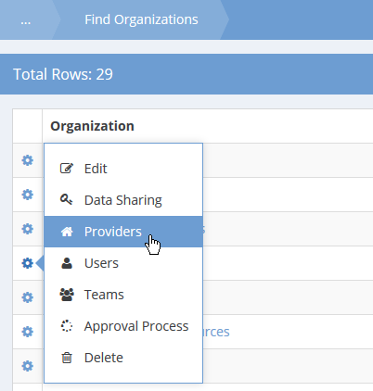

Next to the appropriate Organization, click the action gear and click Providers.

The Providers form displays a list of providers for the organization.

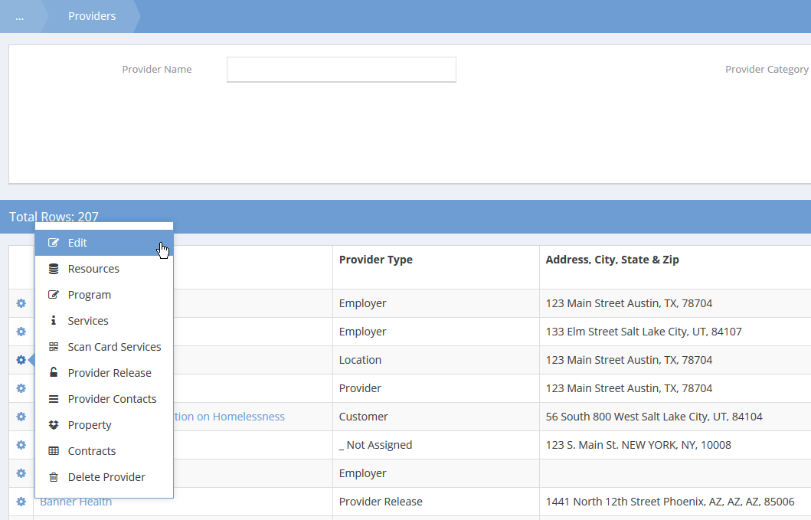

Next to the appropriate provider, click the action gear and click Edit. The Add/Edit Provider form displays.

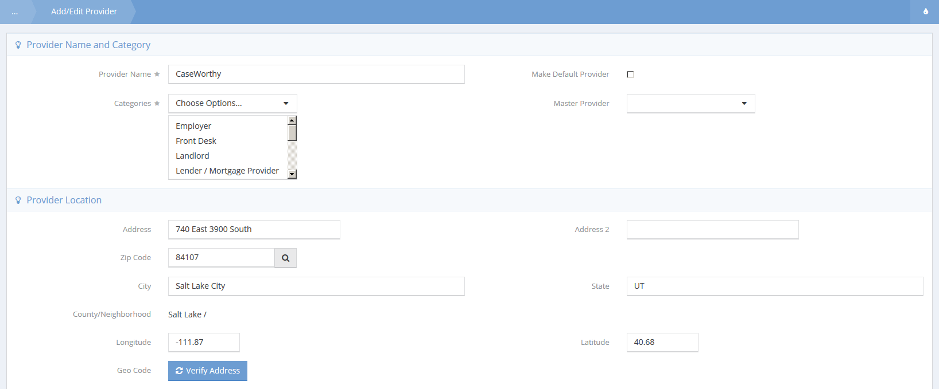

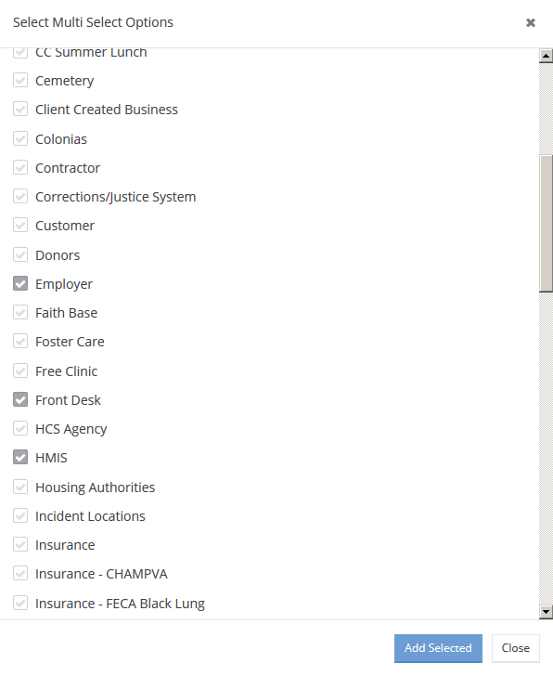

Select the drop down list in the Categories section, click the checkbox for HMIS, and click the button. The HMIS Data Elements section now appears.

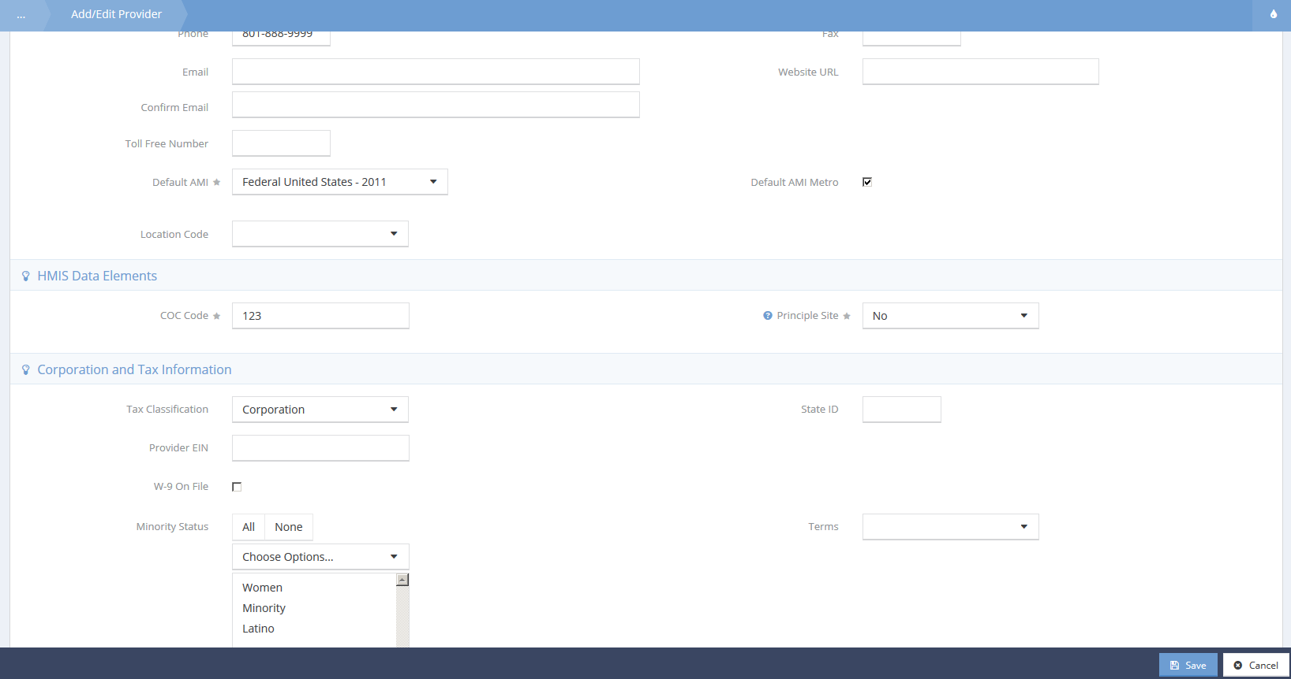

To set up HMIS information for Providers

Type or select the appropriate provider information for HMIS.

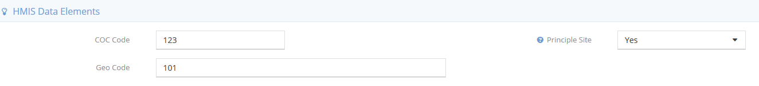

Selecting “Yes” for Principle Site makes the Geo Code field appear.

Program HMIS Set Up
Continue the HMIS HUD APR set up process by recording the appropriate Program information.
To access Program HMIS Setup
In the Administration tab, under Setup, click Programs/Accounts.
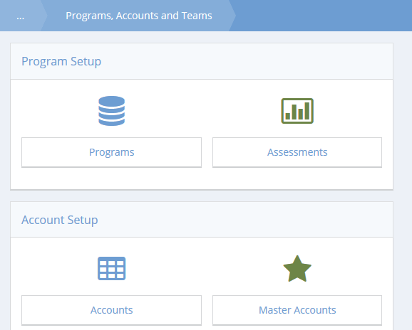

Click the Programs icon.

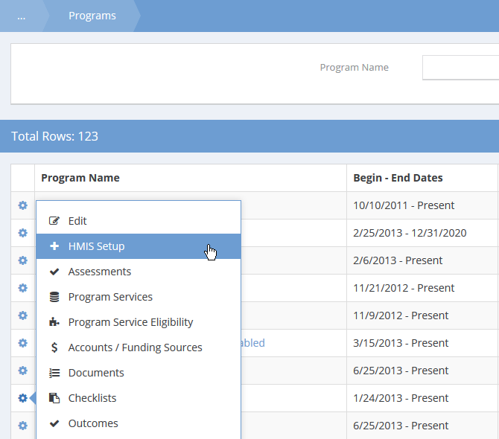

Next to the desired program, click the action gear and click HMIS Setup.

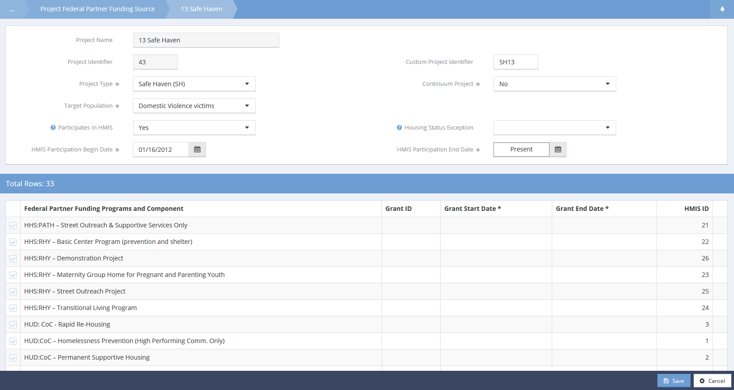

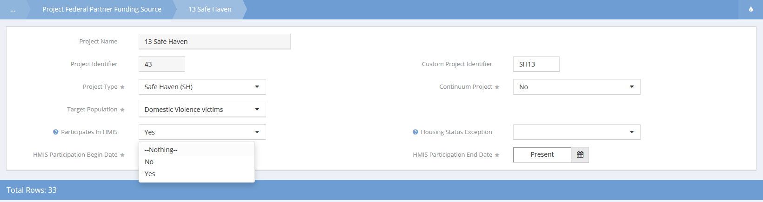

Type or select the appropriate Program information for HMIS. To map an HMIS participating program, click the drop down box for Participates in HMIS and click Yes. Two additional fields appear.

To complete program mapping, select a begin date and end date in the designated fields.

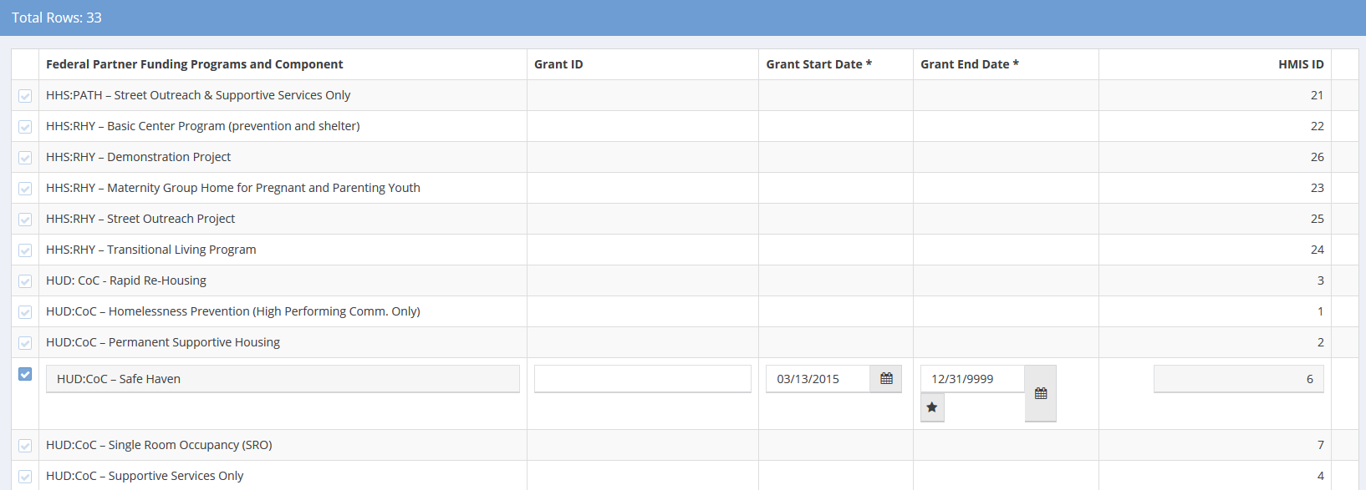

To select Federal Partner Funding Programs and Component, click the clear checkbox and select the date range. Click when done.

NOTE: You only have to set up this information once for all HMIS related reports.

Report Mapping
A number of compliance reports require services and issues be categorized into standard reporting categories. In order to produce a valid report you will need to use these functions to map the services and issues you use operationally to categorize them into standard reporting categories. Report mappings are defined in Administration>Setup>Mappings>Report Mapping.

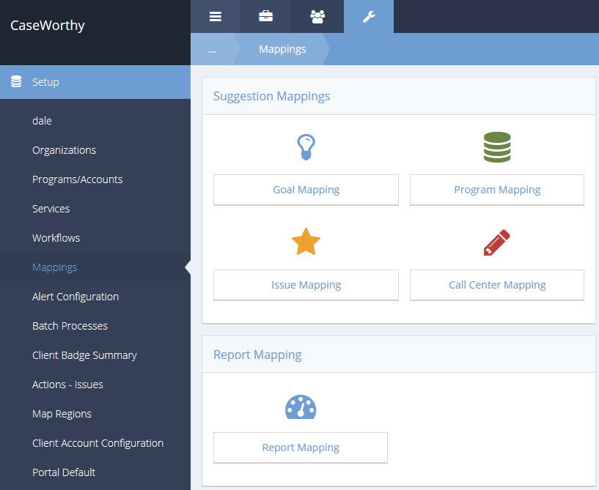

In order to produce a valid report you will need to use these functions to map the issues you use operationally to categorize them into standard reporting categories.

Mapping HMIS Participating Programs
HMIS participating program mapping is now completed in program HMIS set up, which is covered in the previous section. Refer to it for HMIS program mappings.

Launching the Report

Report Launch page options
(Administration>Reporting>Compliance Reports)

To begin report set up, click the CoC APR icon.

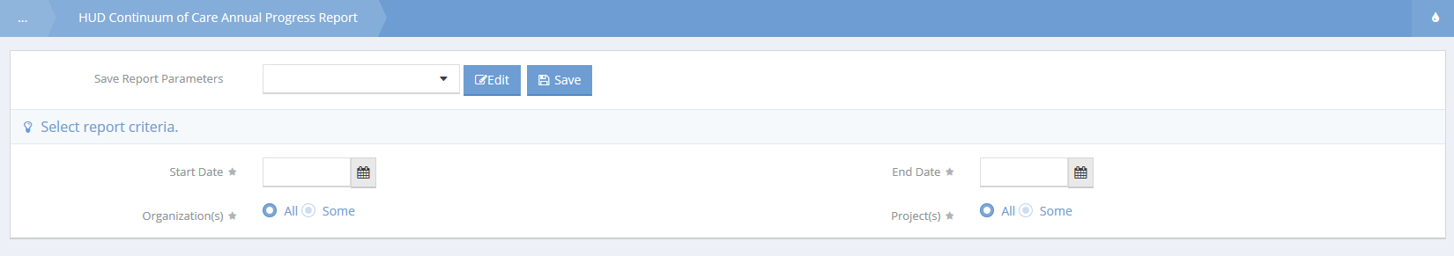

Select the begin and end dates for your reporting period.

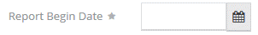

Two multi-select fields will allow users to include any organizations and projects as needed.

Click the button and the report will launch.

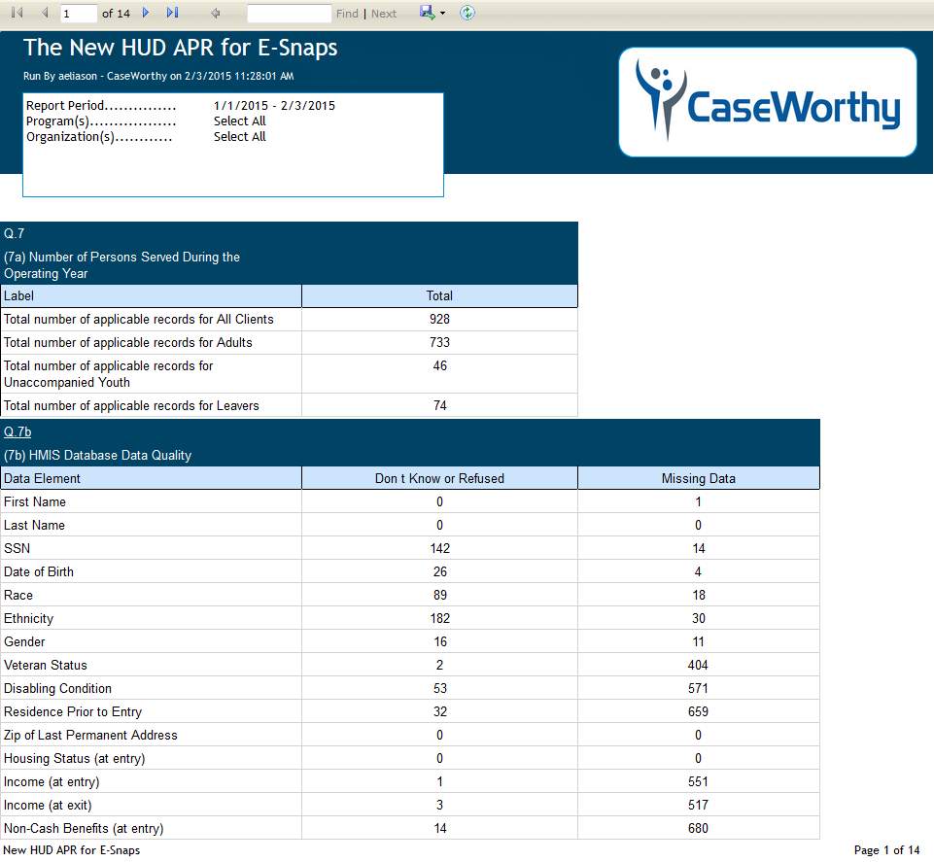

Report Navigation

Navigating the CaseWorthy™ baseline report

The Reports Tool Bar is located at the top of the report page just above the title.

Report pages can be selected by page number or the first page or last page can be selected.

A quick find is located in the reports tool bar to quickly identify specific data.

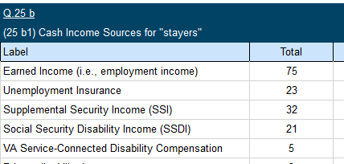

Clicking on white hyperlinked text gives access to a sub-report on specific data.

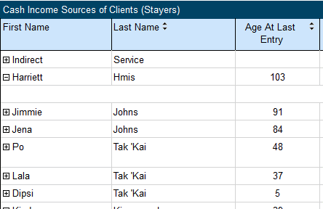

Clicking the plus sign will expand info on a specific item.

To return to the main report from a sub report or drill down, click on the small, blue arrow located in the center of the report tool bar.

Reports can remain open while editing data. To refresh the data, click on the refresh icon.

Exporting Data

Export Icon
On the right-hand side of the tool bar is the export icon.

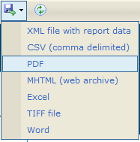
Clicking the export icon will display the available methods. Data may be exported to a number of different database, spreadsheet, and text file formats. CaseWorthy™ provides tools for exporting data to data sources including: XML files with report data, CVS (comma delimited), PDF, MHTML (web archive), Excel spreadsheets, TIFF file, and Word.

Excel Spreadsheet Export
Here’s an example of an Excel spreadsheet export with full report graphics for professional presentations:

