Description of the Statewide/Regional Youth Reports and the Youth Client Lists
Thank you for taking time to learn about the new Statewide/Regional Youth Reports and the Youth Client Lists, which provide an ongoing census of unaccompanied young adults, age 18-24, experiencing homelessness in CT as well as an assessment of the response to young adult homelessness.
Statewide/Regional Youth Reports are accessible to all user roles in HMIS using reporting icon which brings you to Compliance Reports (Org) panel. In addition, CCEH will be sharing the statewide version of the Youth Reports with stakeholders on the 15th of each month.
The Youth Client List is accessible to all user roles in HMIS using the Compliance Reports (Org) Panel. For assistance in accessing this list, please contact Nutmeg for technical support.
Appendix B explains how these reports help measure whether youth homelessness is a rare, brief and one-time experience.
Understanding the Statewide/Regional Youth Reports
The Statewide/Regional Youth Reports include four (4) tables:
  - Table 1 - CAN Appointments
  - Table 2 - Population, Inflow & Outflow
  - Table 3 - Most Recent location of Youth with Open Cases
  - Table 4 - Performance Metrics
Table 1- CAN Appointments
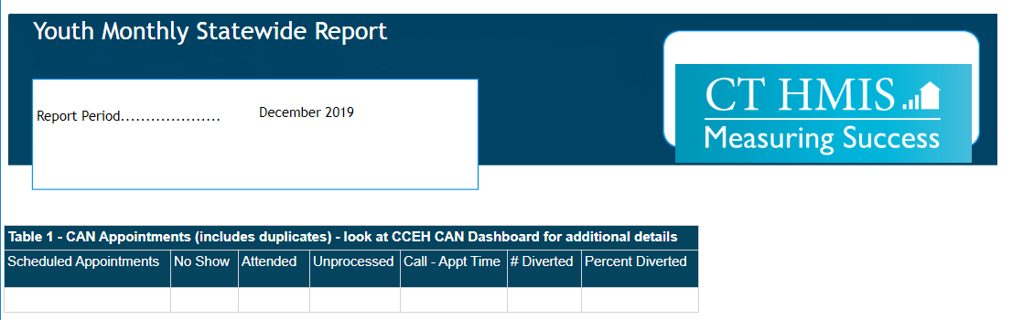
Table 1 provides data on the total number of scheduled CAN appointments for young adult individuals age 18- 24. It further includes the percent of total youth who attended appointments, didn’t attend appointments “no show”, and were diverted as well as unprocessed referrals from 211. Table 1 also includes the total number of youth diverted and average number of days between calling 211 to a scheduled appointment.

Details were retrieved from CT Coordinated Access Data Dashboard on
https://cceh.org/data/interactive/can/
Table 2- Population and inflow & outflow
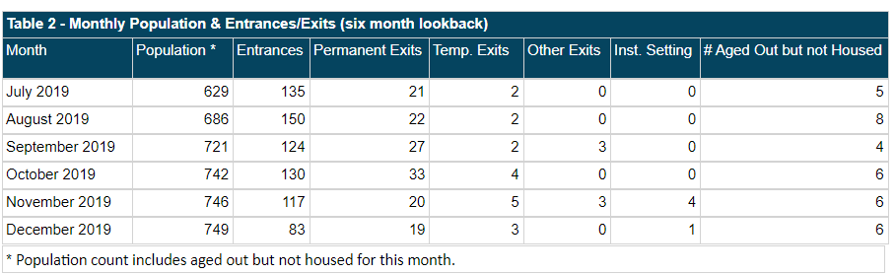
Population - table 2 tracks how the population of youth experiencing homelessness is trending over a six month period. The population includes youth enrolled in most programs: Youth Navigator, Shelter Outreach, Emergency Shelters, Transitional Housing, Diversion/Rapid Exit, Homeless Prevention, Services Only, Rapid Rehousing with no move-in date and Permanent Supportive Housing with no move-in date. It also includes youth who are on the By-Name-List (BNL) but are not currently enrolled in any other program.
Entrances - includes a count of all youth who entered the population, as defined above, that month.
Exits – includes a count of all youth who became inactive on the BNL or exited one of the programs includes in the population, as defined above. Exits are broken into four categories: permanent exits, temporary exits, other exits and exits to an institutional setting. See Appendix A (inserted) for details on these exit categories. Youth who exit a program to homelessness are not counted as an exit and continue to be counted in the population total.
Please note: youth with multiple enrollments may have multiple exits reflected in Table 2. These multiple exits are then de-duplicated for the performance metrics on Table 4. Youth with multiple enrollments, who remain enrolled in at least one of the programs (whether or not they exited a different program) will continue to be included in the population number. It is important that all programs reflect timely and accurate entry and exit data.
Aged Out but not Housed – includes youth who have turned 25 without exiting homelessness and are currently only enrolled in an emergency shelter or shelter outreach program. Or, youth who are on the BNL with no other current enrollments. Youth who have turned 25 but are currently enrolled in transitional housing, a youth navigator program, a diversion or rapid exit program, rapid rehousing with no move-in date or permanent supportive housing with no move-in date will continue to be tracked in the population and in Tables 3 and 4 as well.

Table 3 – Most Recent Location of Youth with Open Cases
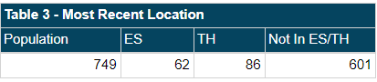
Table 3 gives an account of the most recent location of youth who are currently experiencing homelessness (i.e. youth who are included in the most recent population count). It tracks how many of these youth are currently enrolled in an emergency shelter or transitional housing program. In addition, it includes the amount of youth who are experiencing homelessness but are not residing in an emergency shelter or transitional housing program.
Table 4 – Performance Metrics
Table 4 tracks how swiftly youth are exiting homelessness, the percentage of permanent exits, and the net inflow. These metrics are tracked over both a monthly and 90 day period and are measured in two ways: including transitional housing programs and not including transitional housing programs.
Percentage of Permanent Exits within 45 days: calculates of the youth who were permanently housed, the percent who were permanently housed within 45 days
Percentage of Permanent Exits within 46 to 90 days: the percent of youth who were permanently housed within 46 to 90 days
Percentage of Permanent Exits over 90 days: the percent of youth who it took over 90 days to permanently house
Average Episode Length: calculated using average (mean) number of days from most recent CAN appointment (or program enrollment in absence of CAN appointment date) to date housed
Percentage Permanent Exits: proportion of permanent exits compared to total exits, which includes the de-duplicated number of exits to temporary, permanent, other or institutional locations.
Net Inflow: calculates the difference between de-duplicated entrances and exits (whether outflow is equal to or greater than inflow). If outflow is greater, then net inflow will be negative.
Statewide/Regional Youth Reports Filters
When exporting the reports from HMIS, users can filter the report to include statewide data or data specific to one or more CAN regions. Users can also filter out youth experiencing HUD Category 2 homelessness. However, note that youth who are enrolled in a program as experiencing Category 2 homelessness but also are enrolled in an emergency shelter or transitional housing program or are active on the BNL will be considered experiencing Category 1 homelessness for purposes of these reports when the Category 2 filter in being used.
Youth Client Lists
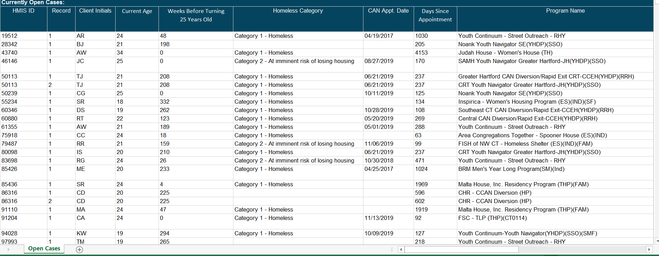

While the Statewide/Regional Youth Reports provide an aggregate overview of youth experiencing homelessness in our system, the Youth Client Lists provide client-level detail on both (a) youth who exited, were housed, or aged out in the past 90 days and (b) youth with open enrollments.
Housed, Exited and Aged out client in the past 90 days.
Column D - HMIS ID: This is generated once a client’s details is enrolled into any HMIS program
Column E - Record: Indicates the most recent enrollment or program client was exited from (all open records of program enrollments will be reflected on the Client List).
Column F - Client Initials: These are first letters derived from client’s first and last names
Column H - Current Age: Calculated using client’s DOB to indicate client’s age as of report date
Column J - Homeless Category: Indicates whether the client is Category 1- Literally homeless, Category 2 – At imminent risk of being homeless or Category 4- Fleeing domestic violence
Column N - CAN Appointment Date: This shows date of the last attended CAN appointment
Column Q - Program Name: Name of program
Column R - Program Enrollment Date: Date client was enrolled in the program named in column Q
Column S - BNL Active Date: This shows when client became active on the By-Name-List (blank means never active)
Column T - BNL Status: This indicates if client status is active or inactive on the By- Name- List (blank means never active)
Column U - Aged Out: States if client aged out while enrolled before case became closed or exited.
Column V - Days since CAN Appointment: Calculates number of days between CAN appointment date or program enrollment begin date and date client was reported to have exited a program or moved into housing.
Column W - Move-In/ Exit Date: Date client is noted to have moved-in to housing or exited program.
Column X - Exit Destination: Details clients exit destination (unless client has a move-in date only with no program exit yet)
Column Y- CAN Column: CAN client was enrolled in.
Column Z – Services in the last 90 days: Indicates if client received was enrolled in any of these programs (Youth Navigator, Shelter Outreach, Emergency Shelters, Transitional Housing, Diversion/Rapid Exit, Homeless Prevention, Services Only, By- Name-List, Rapid Rehousing with no move-in date and Permanent Supportive Housing with no move-in date) within past 90 days

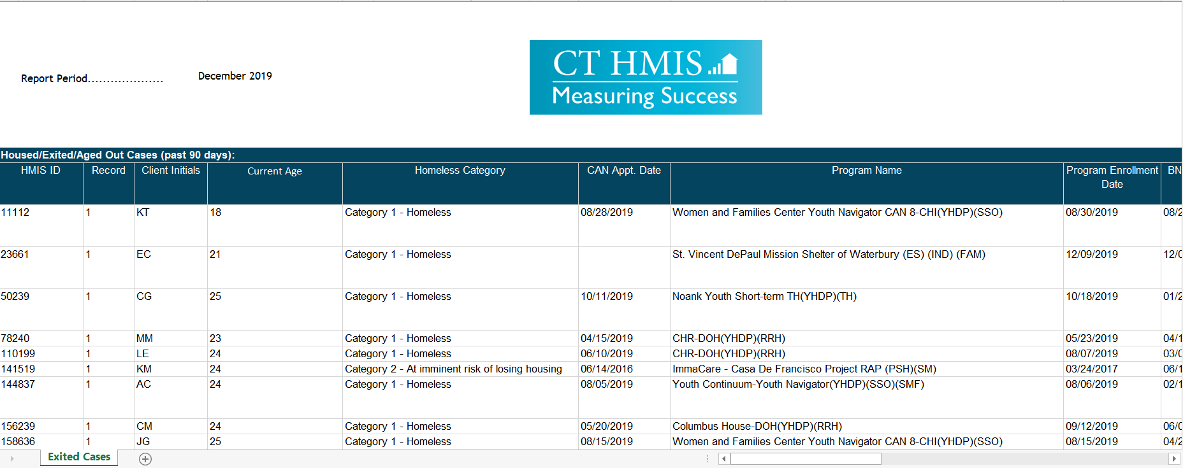

Currently Open Cases:
Column B - HMIS ID: This is generated once a client’s details entered into any HMIS program
Column C - Record: Indicates total number of enrollments with the most recent enrollment depicted as 1 and previous enrollments indicated in ascending order
Column D -Client Initials: These are first letters derived from client’s first and last names
Column E - Current Age: Calculated using client’s DOB to indicate client’s age as of report date
Column F -Weeks before turning age 25: Calculated using client’s DOB to indicate length of time before a client becomes 25 years old. For clients aged out but retained this value will be represented as 0 indicating that they have turned 25.
Column G - Homeless Category: Indicates whether the client is Category 1- Literally homeless, Category 2 – At imminent Risk of being homeless or Category 4- Fleeing domestic violence
Column H - CAN Appointment Date: Date client attended a CAN appointment
Column I - Days since Appointment: Calculates number of days between CAN appointment date or program enrollment begin date (in absence of CAN appt. date).
Column J - Program Name: Program name
Column K - Program Enrollment Date: Date client was enrolled in the program named in column J
Column L - BNL Active Date: Date client became active on the By-Name-List (as applicable)
Column M -VI-SPDAT Score: Client’s most recent VI-SPDAT/Next Steps Tool score
Column N - BNL Status: Indicates if client status is active or inactive on the By- Name- List (blank means never on BNL)
Column O - BNL Sub-status: Indicates if client is Housed, Matched to a housing program, Enrolled in CAN by default or in an Institution.
Column P – BNL Sub Status Date: Indicates when client sub status became active
Column Q – BNL Unsheltered: Indicates if client is marked unsheltered on the BNL
Column R- CAN Column: CAN client is enrolled in.
Column S - Services in the last 90 days: Indicates if client received was enrolled in any of these programs (Youth Navigator, Shelter Outreach, Emergency Shelters, Transitional Housing, Diversion/Rapid Exit, Homeless Prevention, Services Only, By- Name- List, Rapid Rehousing with no move-in date and Permanent Supportive Housing with no move-in date) within past 90 days

Appendix A:
Appendix B:

